Submitted By:

Muhammad Umair 2015-CS-05

Huma Nawaz 2015-CS-116

Rabeeya Saleem 2015-CS-160

Batool Gohar 2015-CS-161

Submitted To:

Dr. Muhammad Awais Hassan

Dr. Tauqeer Ahmed

Feasibility Report

Semantic Based Knowledge Learner

**TABLE OF CONTENT**

**­­**1.1 Introduction…...……………………………………………………… 2

1.1.1 Overview of project………………………………………………….. 2

1.1.2 Background…………………………………………………...……… 2

1.1.3 Motivation……………………………………………………………. 2

1.1.4 Objectives…………………………………………………………….. 3

1.1.5 Scope ………………………………………………………………… 3

1.1.6 Target Audience……………………………………………………. .. 3

1.1.7 Possible application of work…………………………………………3

1.2 Existing Systems…………………………………………………….. 4

1.2.1 Comparison of Existing Systems……………………………………. 4

1.2.2 Drawbacks of Existing Systems……………………………………... 4

1.2.3 Survey on existing systems and limitation………………………….. 4

1.3 Problem Statement…………………………………………………... 5

1.4 Proposed System………………………………………………..….... 5

1.5 Tutorial Session ………………………………………………..….... 5

1.6 Feasibility Study…………………………………………………….. 32

1.6.1 Technical Feasibility………………………………………………… 32

1.6.2 Operational Feasibility………………………………………………. 37

1.6.3 Economic Feasibility……………………………………………..….. 37

1.7 Project Plan……………………………………………..…………… 37

1.8 Wireframes……………………………………………..…………… 38

1.9 System Requirements……………………………………………..…. 42

1.9.1 Hardware Requirements……………………………………………... 42

1.9.2 Software Requirements……………………………………………… 42

1.10 Limitations and challenges in implementation of project……….…... 43

1.11 References …………………………………………………………… 43

**1.1 Introduction**

**1.1.1 Overview of Project:**

The evolution of information society has led to the emergence of new technologies and environments. One of the most important requirements to such environments is the rapid access to the relevant knowledge that meets News Anchor’s needs as precisely and fully as possible. This semantic base news aggregator is about building an appropriate infrastructure for intelligent agents to run around the Web performing complex actions for their users. Furthermore, our system is about explicitly declaring the knowledge embedded in many websites integrating information in an intelligent way, providing facility to News Anchor and extract desired news from stored database in result of time and cost saving. As in previous system, News Anchor have to do manual work for storing news and for extraction desired output, hard work is needed. But, in our knowledge learner, system will be more secure and lessen the burden to store and extract news. It is basically a graphical representation of a specific field. Each information is stored in database in the form of graph that can be easily extracted for later use. It helps us to gain knowledge from online resources as well as in general. Semantic Base knowledge learner for News Channel is about how to implement reliable, large-scale interoperation to make such services computer interpretable, services that intelligent agents can discover, execute, and compose automatically.

**1.1.2 Background:**

How can you find the rightinformation about a particular topic from this vastocean of data?

depends on who wantsto find the right information, whether it is a human being or a machine.

Search engines have become so important because it helps us retrieve various information about a

particular topic. But human beings are capable to compare the different webpages and make an

informed choice because, we understand the ‘meaning of the information’.

How can you find the rightinformation about a particular topic from this vastocean of data?

depends on who wantsto find the right information, whether it is a human being or a machine.

Search engines have become so important because it helps us retrieve various information about a

particular topic. But human beings are capable to compare the different webpages and make an

informed choice because, we understand the ‘meaning of the information’.

How can you find the rightinformation about a particular topic from this vastocean of data?

depends on who wantsto find the right information, whether it is a human being or a machine.

Search engines have become so important because it helps us retrieve various information about a

particular topic. But human beings are capable to compare the different webpages and make an

informed choice because, we understand the ‘meaning of the information’.

How can you find the right information about a particular topic from this vast ocean of data depends on who wants to find the right information, whether it is a human being or a machine? Search engines have become so important because it helps us retrieve various information about a particular topic. But human beings are capable to compare the different webpages and make an informed choice because we understand the ‘meaning of the information’.

Semantic Web is the evolution of the WWW due to the enhancement in other parallel technologies like pervasive computing, sentient computing, internet of things, artificial intelligence etc. Semantic Web tries to classify the data based on different topics and assign meaning to it.

The Web infrastructure currently is a distributed network of interlinked webpages with Unique Resource Locators. This helps to categorize webpages of a particular niche and identify them. The idea of Semantic Web is to push the very same infrastructure, where the linking of resources is on the data level. Semantic Web is based on the idea of Smart Data. Smart Data is interlinked data that allows not only humans to use the information, but machines too. Even if each entity of the data is held by individual organization, since they are all interlinked, it could make more meaning.

**1.1.3 Motivation:**

Newscasters face many problems in gathering what to report and then arranging and archiving the news. It has been a hectic and time-consuming task for the people who are doing this job. The main motivation for making this project is to help the newscasters in gathering the news from online resources as well as in general and storing them in the most efficient way so that they can be easily approached for later use.

**1.1.4 Objectives:**

**Industry Objectives:**

The main objective of this project is to collect the timely news according to need. That is, news anchors spend a lot of time in gathering news, formatting them for the news casting and thus archiving them for the backup of the news. This whole process takes a lot of time. Thus, making this whole process automatic, saves a lot of time as well as improves performance. Hence, Semantic based knowledge learner would do the same in a very short time and in better quality, i.e. collect the timely news through different resources, save them in graph databases for the retrieval process later.

**Research Objectives:**

In the development of Semantic based knowledge learner, graph databases are used. Graph databases are very vital in the field of research. Although there are some research issues with graph databases, however it has importance in the research field along with semantic web technologies.

**Academic Objectives:**

Semantic Web is used to implement an e-learning system proficiently by enhancing

the current search mechanism. E-Learning is the delivery of learning material to learner without any constraint on time and place. It can be viewed as a dynamic and flexible approach in contrast to traditional learning. Thus, Semantic based news aggregator technology offers personalized and flexible access to the learning resources with the help of ontology-based descriptions of content, context and structure of the learning materials/news.

**1.1.5 Scope of the Project:**

In this project, text and file except images will be handled and interpreted. Whenever we want to extract data we can get it through some customized functionalities. Our project can be used by anyone having knowledge about semantics.

**1.1.6 Target Audience:**

Targeted audience will be the:

* Newscasters
* News viewers
* News aggregator

**1.1.7 Possible Applications of Work:**

The possible application of work for our project are as follows:

* News aggregator
* History Record
* Stock Exchange Record
* Flight Records (Airport)
* Inventory and Stock
* Bank
* Institutional records.

**1.2 Existing Systems:**

**1.2.1 Comparison of Existing Systems:**

* **Existing system** collects the knowledge/news through online documents/papers while in **our system**, along with the collection of knowledge through web scraping, we would be able to store information/news manually, it can be a transcript of a person’s speech or the news of a TV channel.
* **Existing systems** usually use RDF tipple stores for the storage of information using RDF or more of Semantic graph database. But in **our system**, we will implement the Neo4j graph databases which provides efficient storage that would allow for fast querying and fast traversals across connected data.

**Neo4j vs RDF:**

* Rich internal structure is absent in RDF whereas it exists in Neo4j.
* The magnitude of the size of RDF is bigger than the Neo4j.
* In RDF, we don’t have attributes in relationships and we have to create an intermediate node, but in Neo4j does.
* Queries are complicated in RDF as compared to Neo4j.
* Neo4j is efficient in storing/merging information related to database and in retrieval of information as well.
* Graph databases can store various types of graphs, including undirected graphs, weighted graphs, hypergraphs, etc. RDF triple stores focus solely on storing rows of RDF triples.
* Graph databases are better optimized for graph traversals (degrees of separation or shortest path algorithms). With RDF triple stores, the cost of traversing an edge tends to be logarithmic.
* **News aggregators** usually collects news through online documents and then after analysing, presents it in the form of magazine or some other user readable format. Whereas in **our system** after collection of the news/information, graph database is prepared. And we can apply our questioning in the form of queries to get our desired results along with the regular results presented in a traditional method.

**1.2.2 Drawbacks of Existing Systems:**

**Structured Limitations:**

Technologies used by current systems for information storage contains the structure limitations. That is there is much less flexibility in data storage.

**Lack of custom queries:**

Current systems collect news through online docs and present them in certain statistics built in these systems. There is no pattern of custom information retrieval.

**1.2.3 Survey on existing systems and limitations**

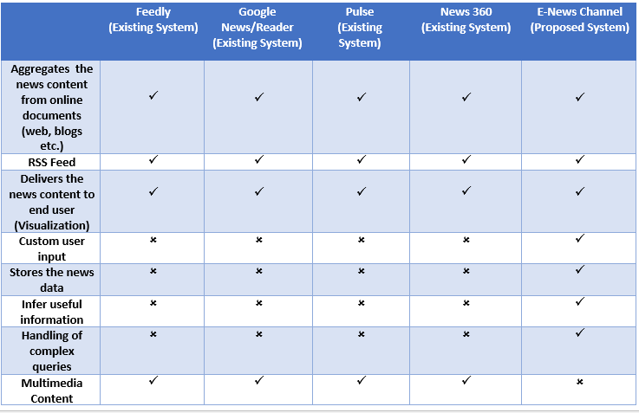

**1.3 Problem Statement:**

To develop a Semantic Based Knowledge Learner aggregator of news data that stores it in graph databases and we can infer useful information by using complex queries for the convenience in the field of news anchors by presenting information in useful format.

**1.4 Proposed System:**

Semantic based knowledge learner is a system which would collect the news either through online news resources (blogs, online magazines, websites, other internet resources excluding images, videos etc.) or manually by a transcript feeding (speech, TV channel, podcast). After collection of information, this system will store these in a very efficient database where custom queries are relatively feasible along with proper publishing of news.

**1.5 Tutorial Session**

Technically, in Semantic Base News Aggregator and Extractor we are required to use some sort of graph database because database relations are not straight forward also changes may be occurring after the implementation. Rest of this, we have to extract desired output for this it’s easy to get answers from Graph database rather than Relational Database. For Database, some software, IDEs and packages are required to be installed.

For Graph Database handling we have to use Neo4J with cypher Query Language

1. Download Neo4j

* for Downloading Neo4j follow a link <https://neo4j.com/download/>

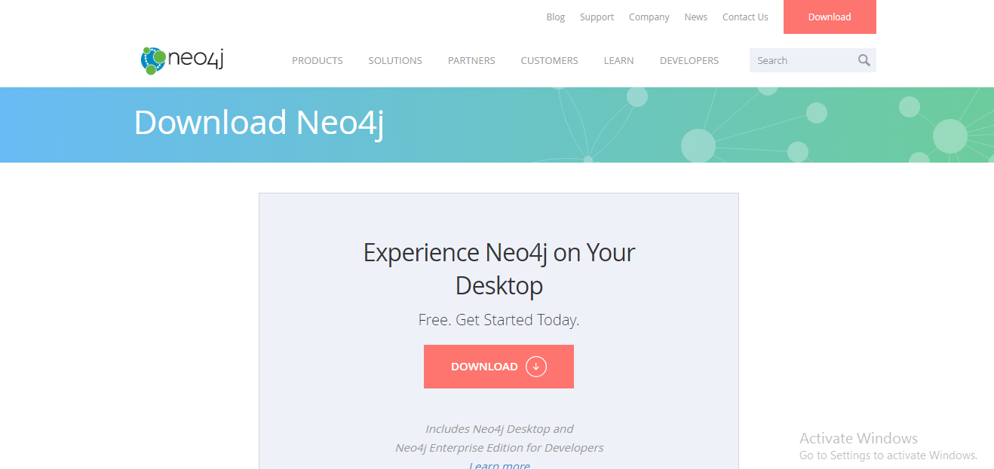

* Click on Download Button and then Fill the required form to downloading desktop Neo4j setup

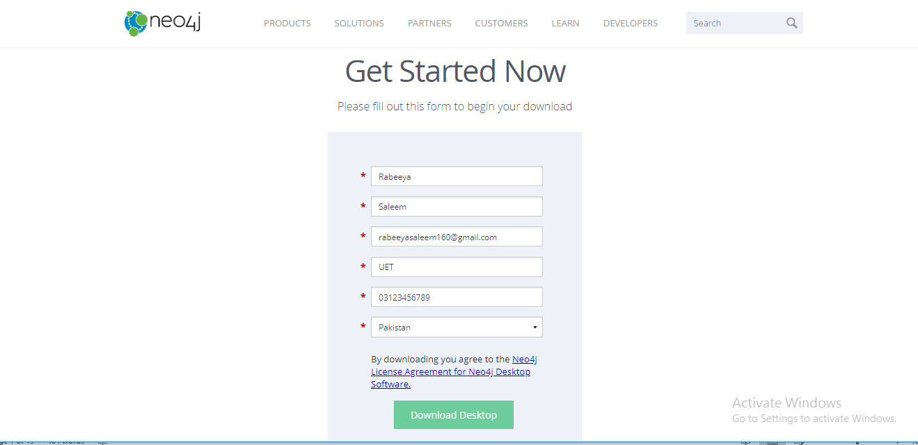

1. Starting with Neo4j

* After downloading and installation of neo4j is being set, create a new project.

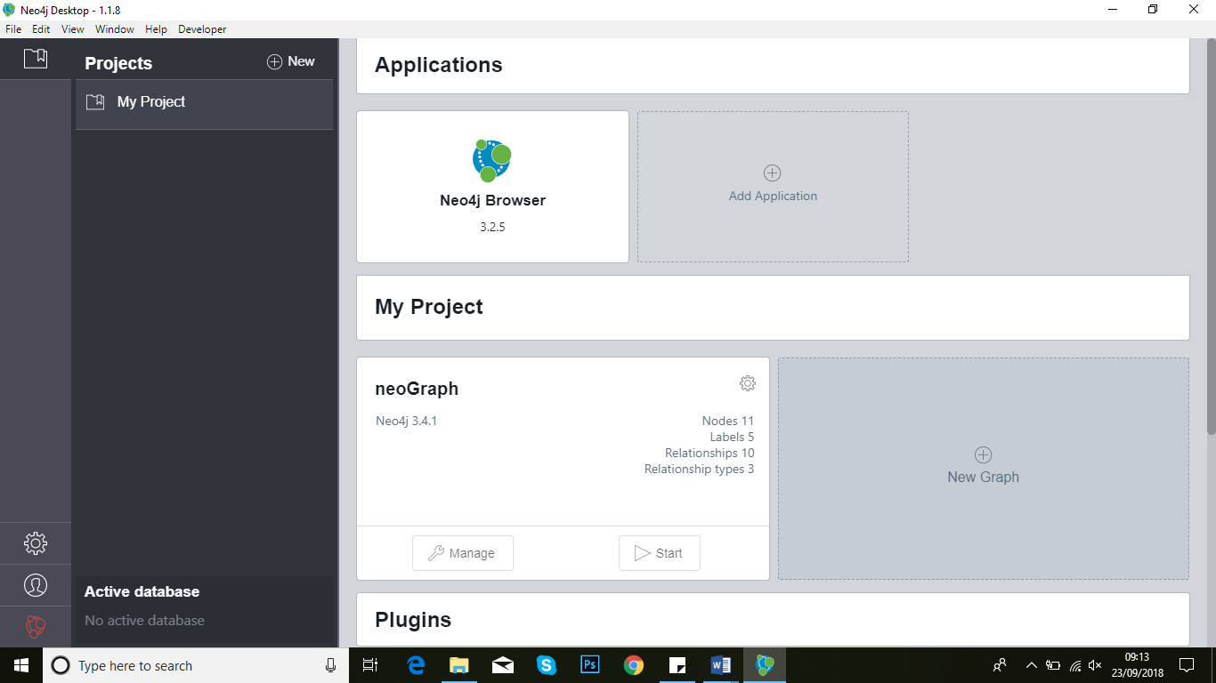

* Start with Neoj Click on Create a Local Graph button.

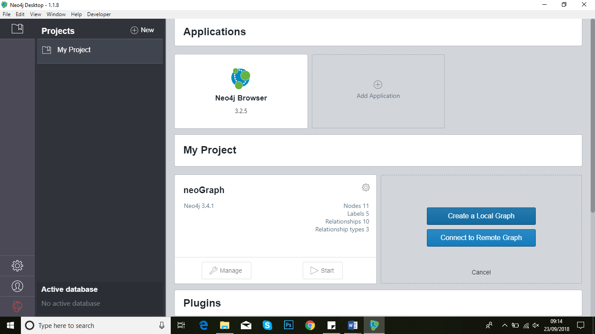

* Set name and password (try to use default Password as ‘neo4j’) of your graph database by click Create button.

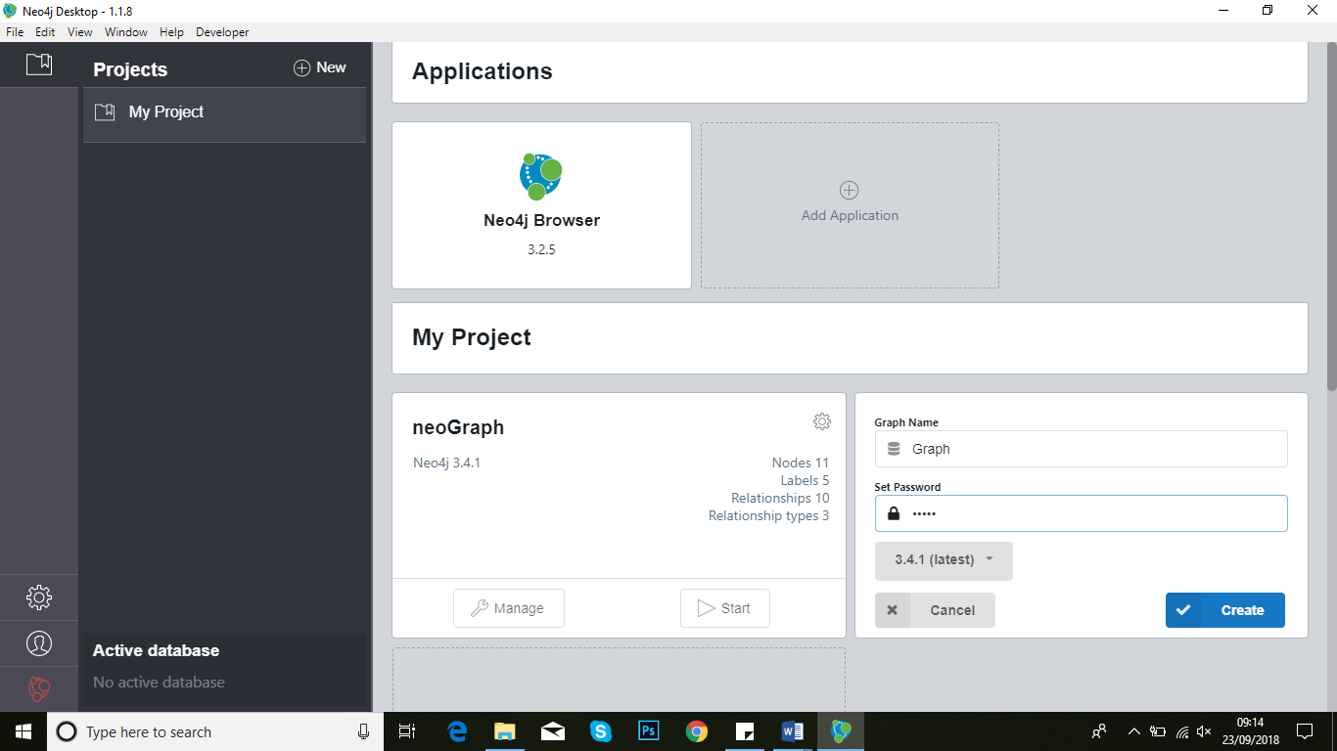

* To start working with neo4j click on Start Buttn , a new Screen will open where u will play with nodes and relationships between objects.

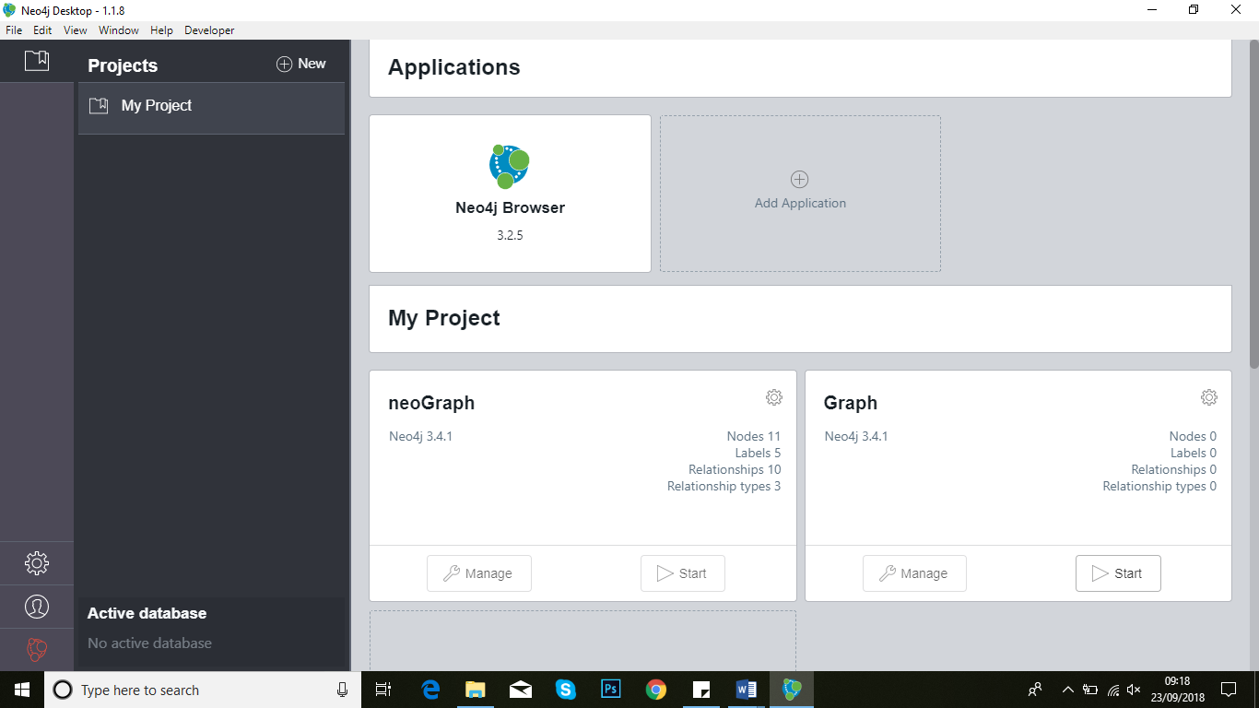

* Now click on Manage Button for a link to open neo4j in browser.

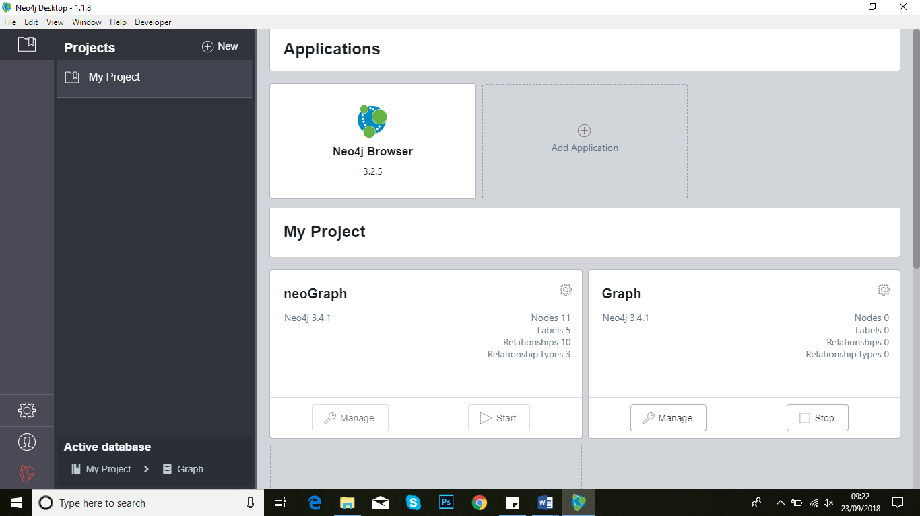

* Here is some port value of Neo4j setup as HTTP port and Bolt port that can be changed.

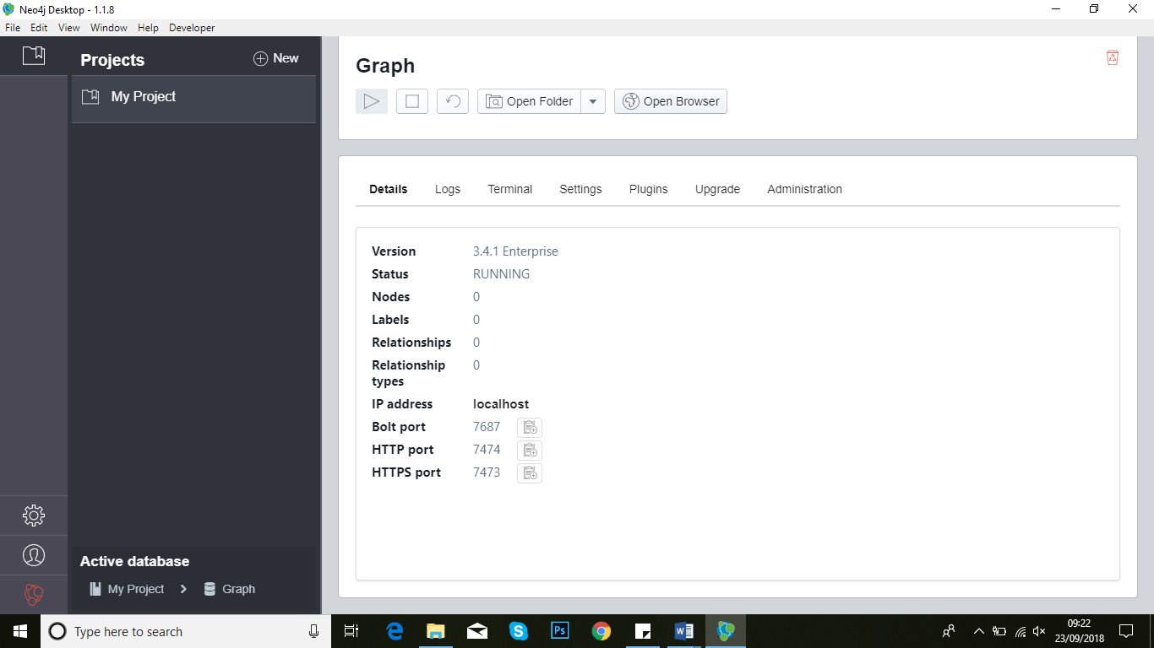

1. Follow this link to open neo4j in browser as localhost:7474 (as per HTTP Port number).

* Enter you Username and Password(that u set during creation of graph) and click on ‘Connect’ button.

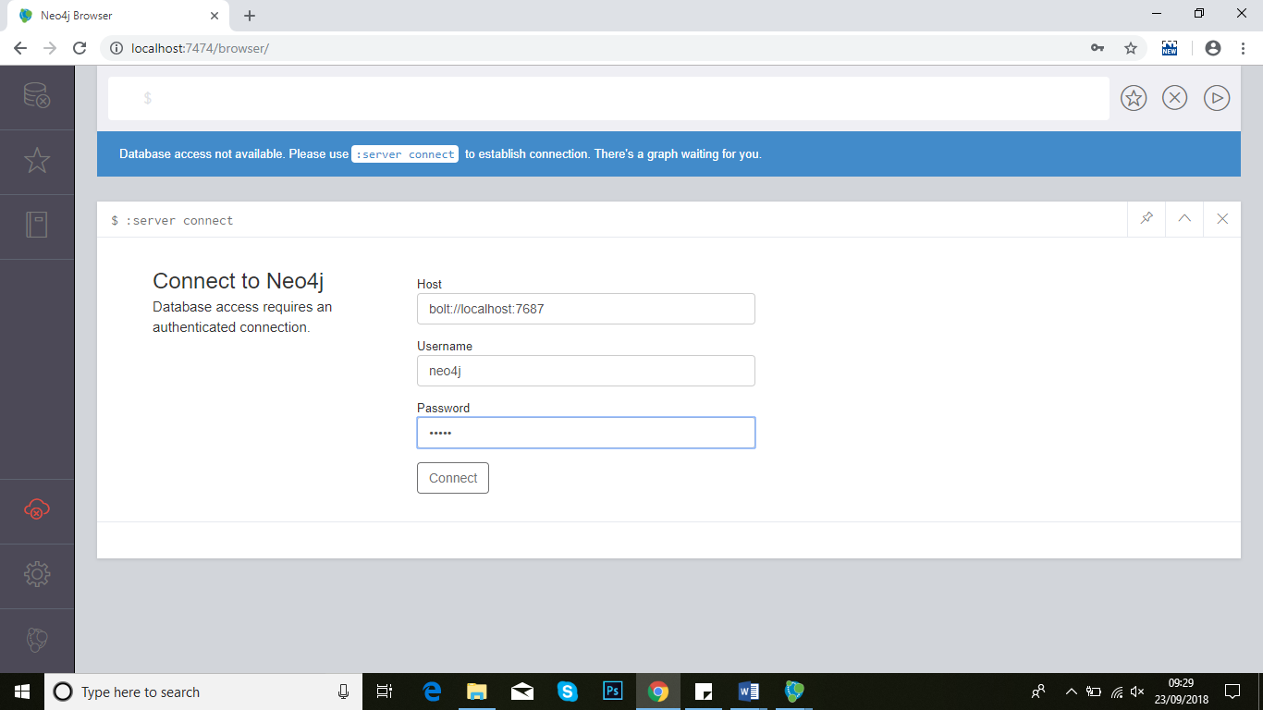

* Neo4j setup is ready to run for desktop and browser as well.

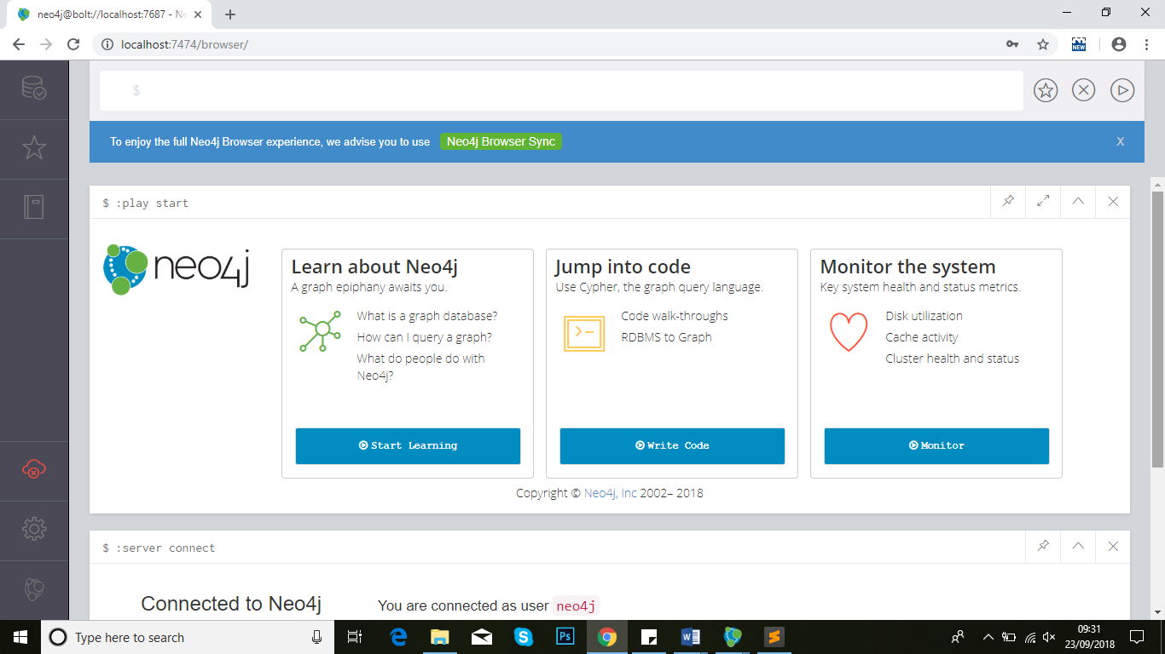

1. After setting up neo4j setup, starting with cypher query language and create node and relationship

* Create a Node

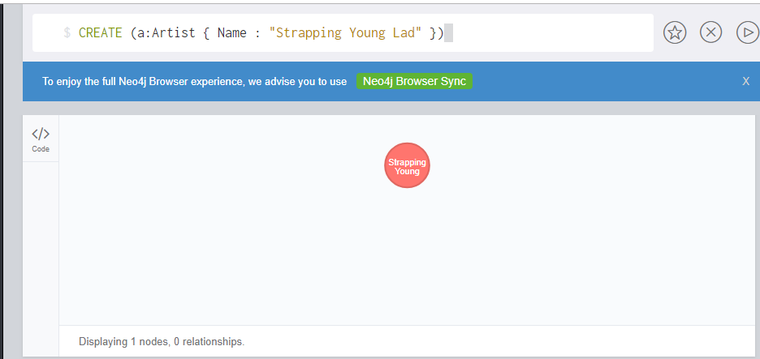

* Create Multiple in a single query

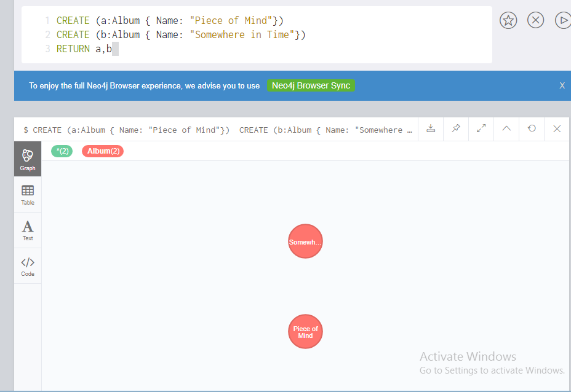

* Create a single relationship between two nodes

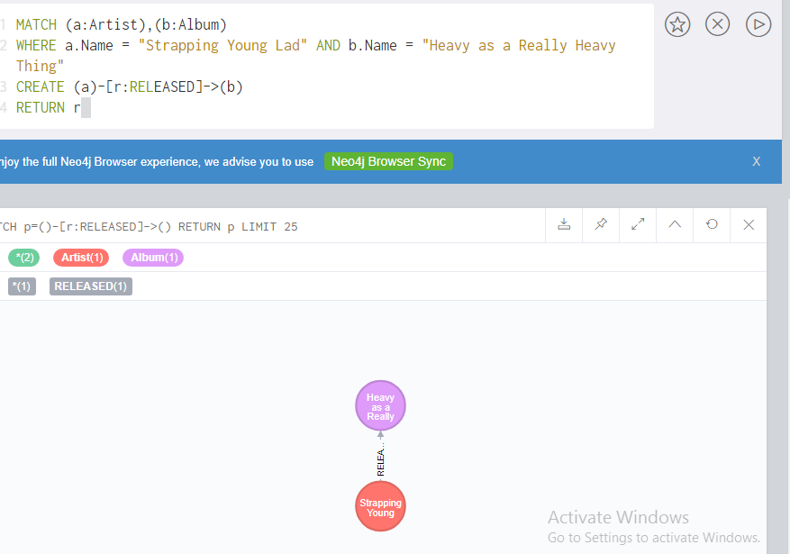

* Create multiple relationships between multiple node

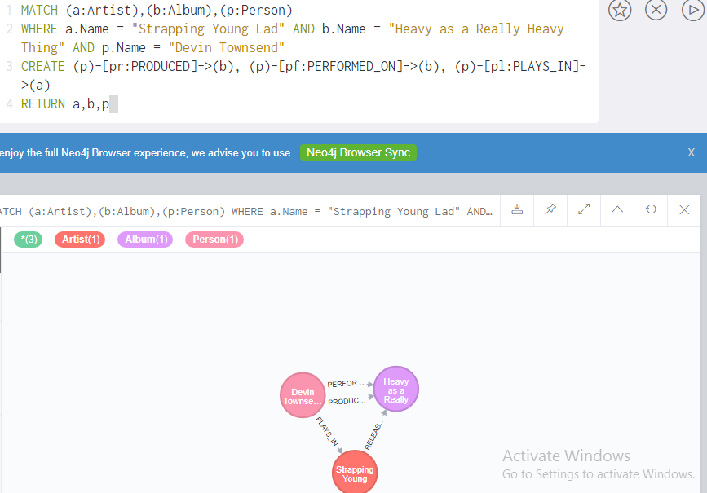

1. After this we are required to download python IDE for python language that will create connection between User Interface and Graph Database.

* Download link for python is <http://www.python.org/download>.
* Install rest client and flask by using run your project from

D:\ Rabeeya\neo4j\neo4jDatabases\database-02a06aac-070c-4df6-96cd-6e3c01c96cbb\installation-3.4.5\bin.

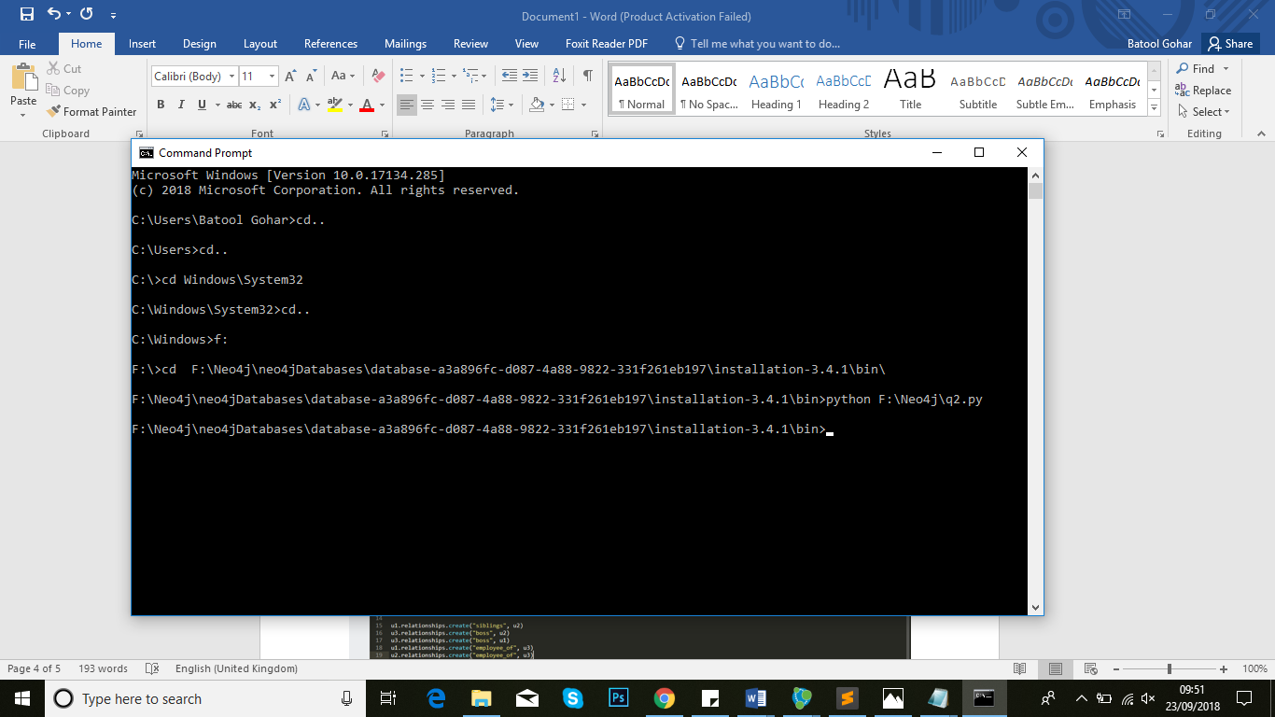

* Creat a file in any of source code editor with name of name.py and write code for creating node and relationship through pyhton.

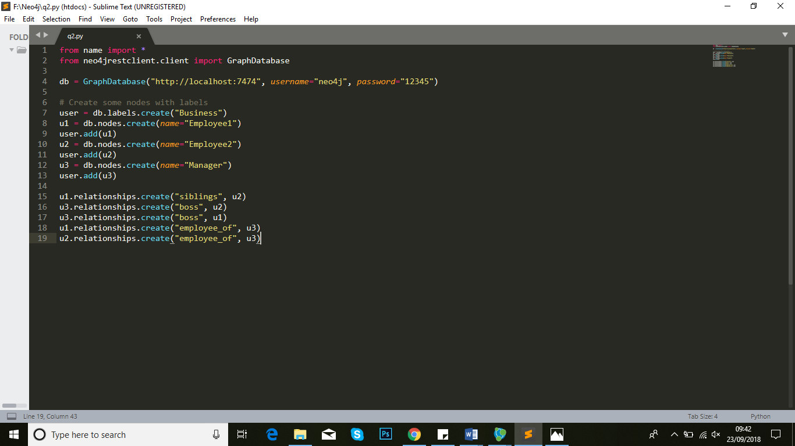

* After compilation of given code nodes and relationship created successfully in neo4j graph.

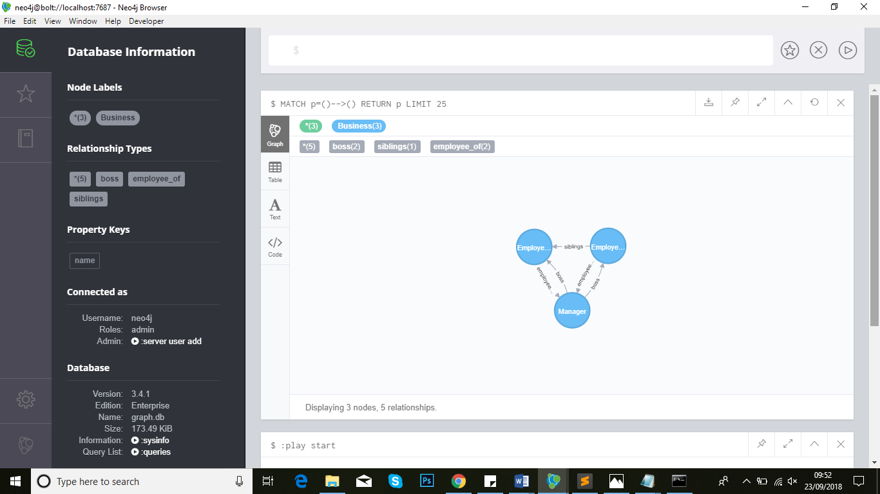

1. To handle graph database, we have to use FLASK that will connect with python and through RestClient graph created in Neo4j.

* Now install flask using command of install flask

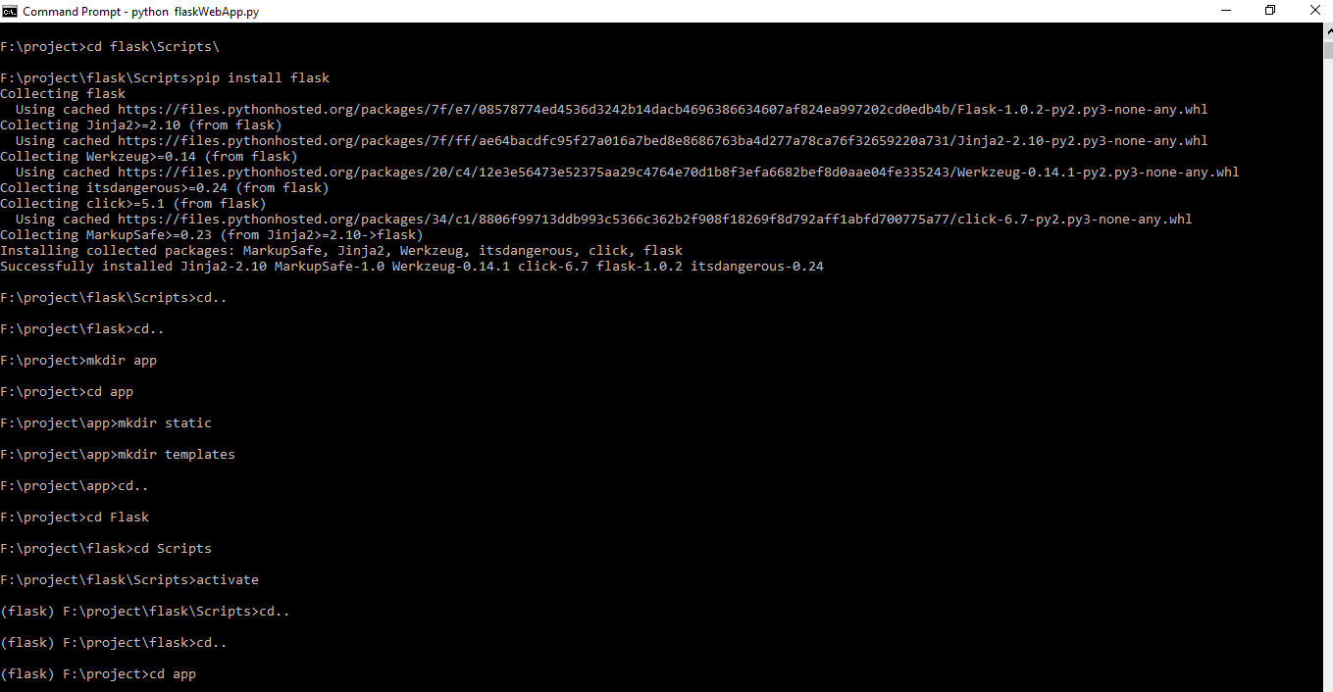

* Create a simple File and write code in it

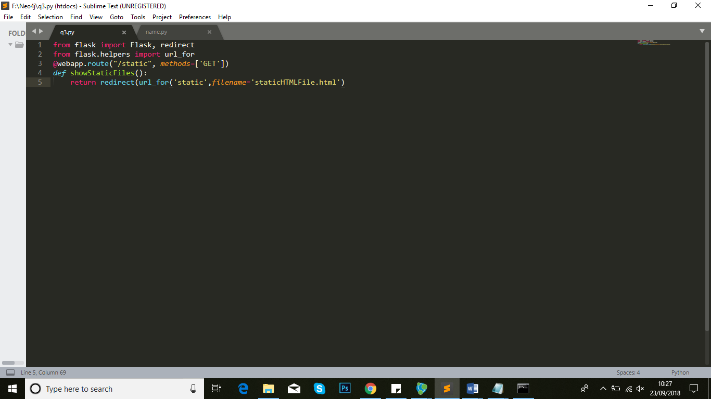

* To run this flask file, follow these commands

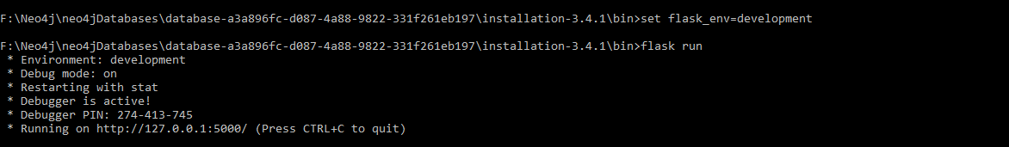

* Now set virtual env using cmd Command

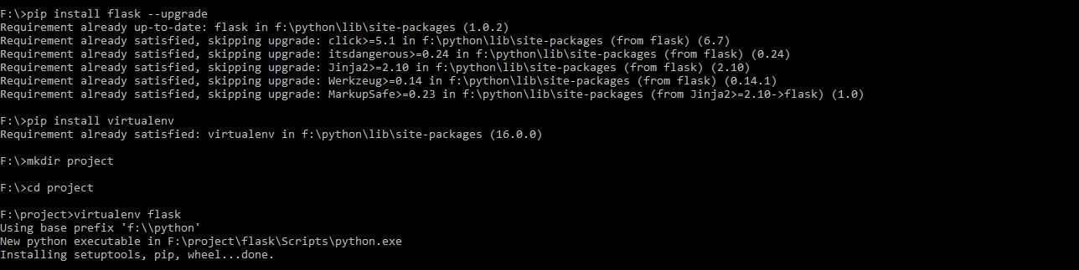

* Then install flask in new created project



* Now create a file with name WebApp.py in editor and write a code as bellow.

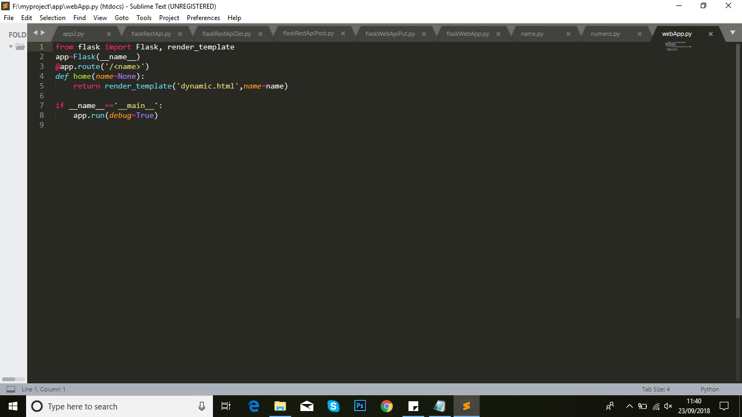

* After this run this file as

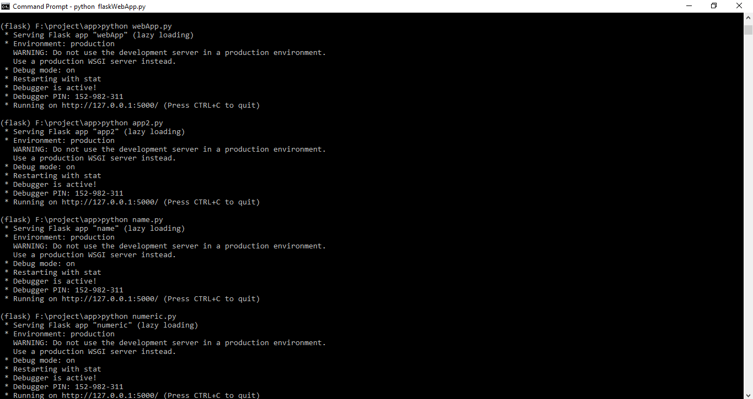

* Now create a file with name app2.py in editor and write a code as bellow.

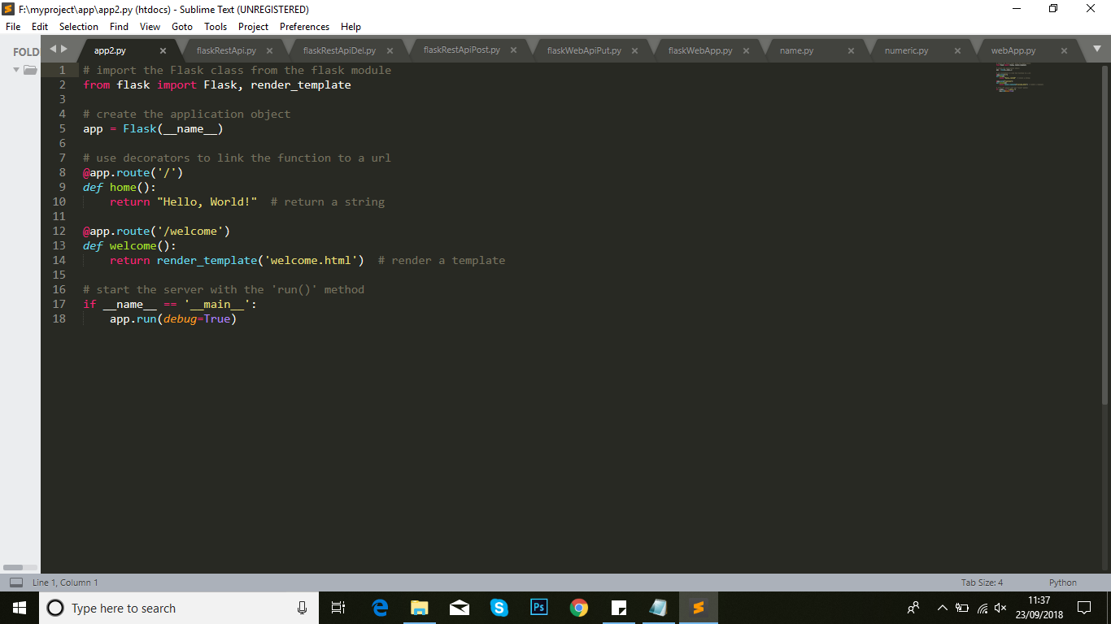

* After this run this file as



* Now create a file with name name.py in editor and write a code as bellow.

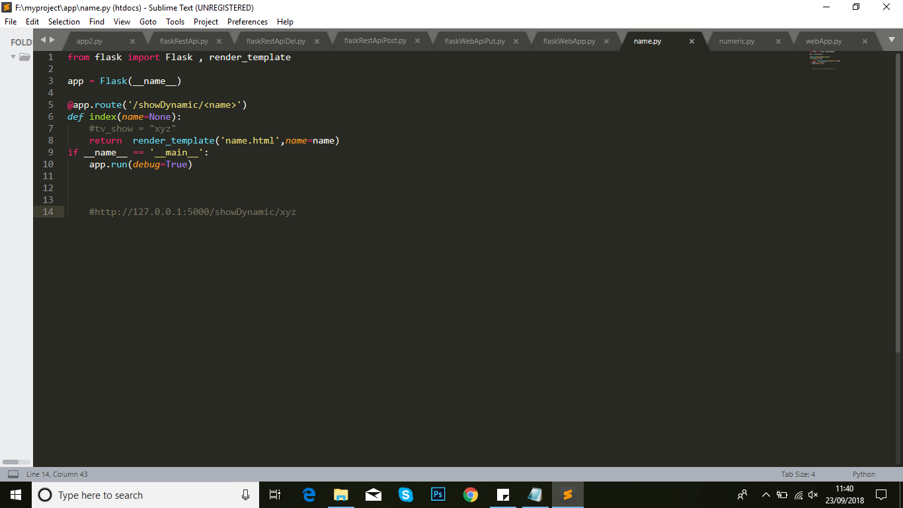

* After this run this file as



* Now create a file with name nummeric.py in editor and write a code as bellow.

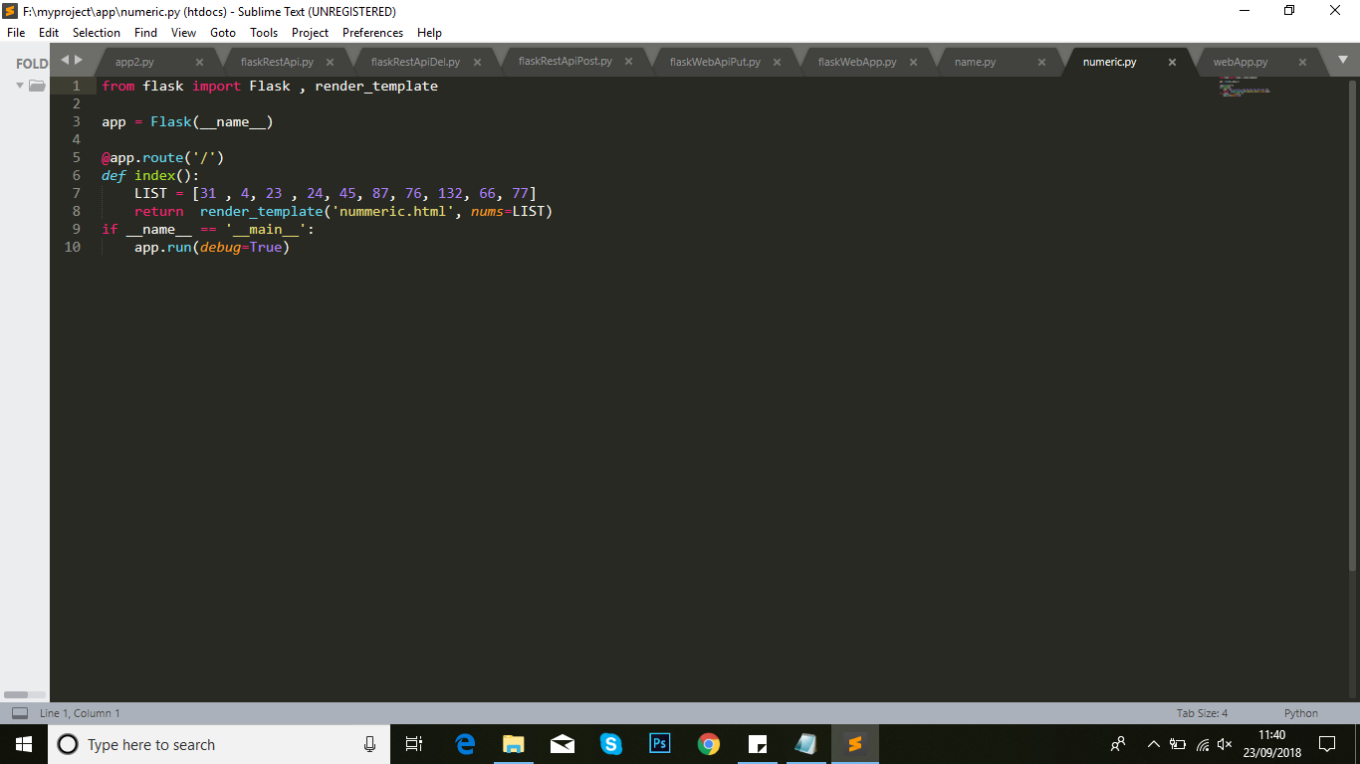

* After this run this file as



1. For Rest-Api, postman setup is used to analysed what changes will occur.

* To download latest setup of Postman visit this link <https://www.getpostman.com/> after this install this setup.
* Now create a file with name flaskRestApi.py in editor and write a code as bellow.

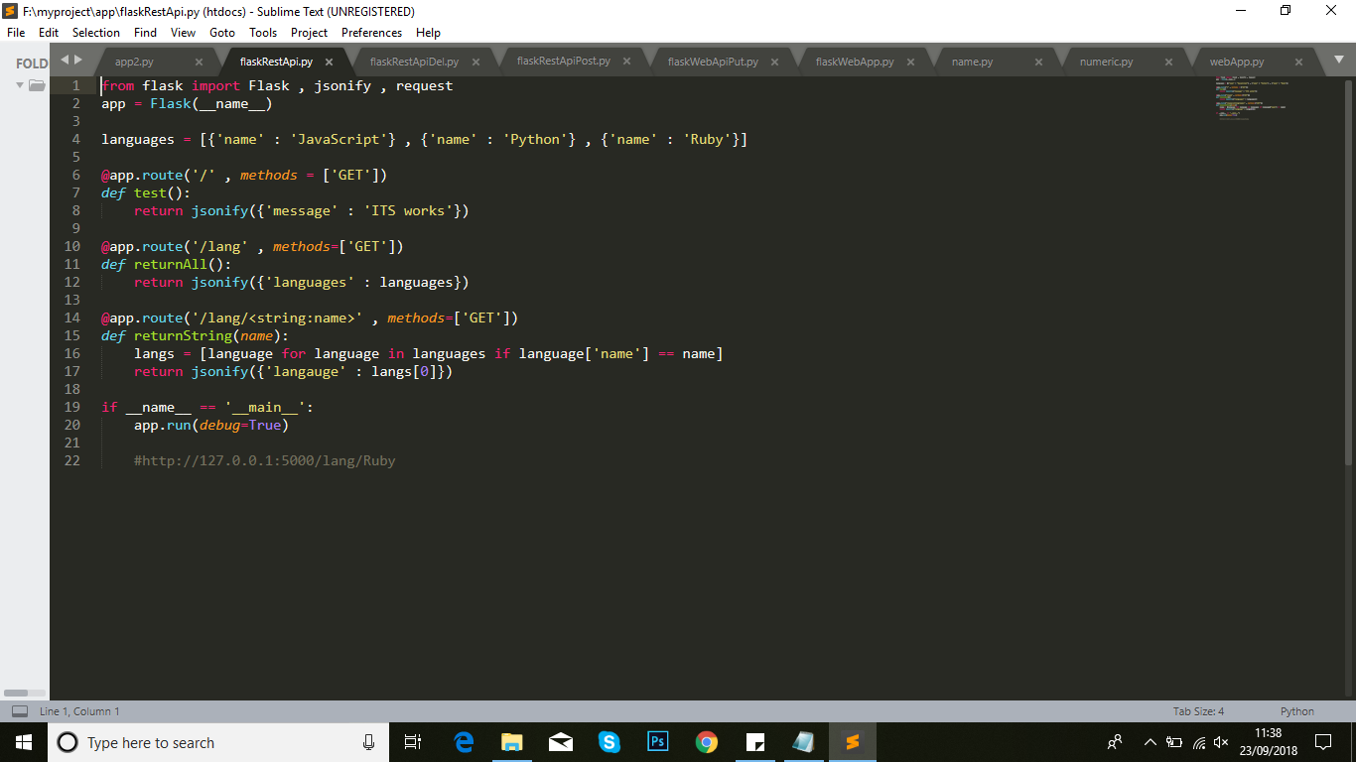

* After this run this file as

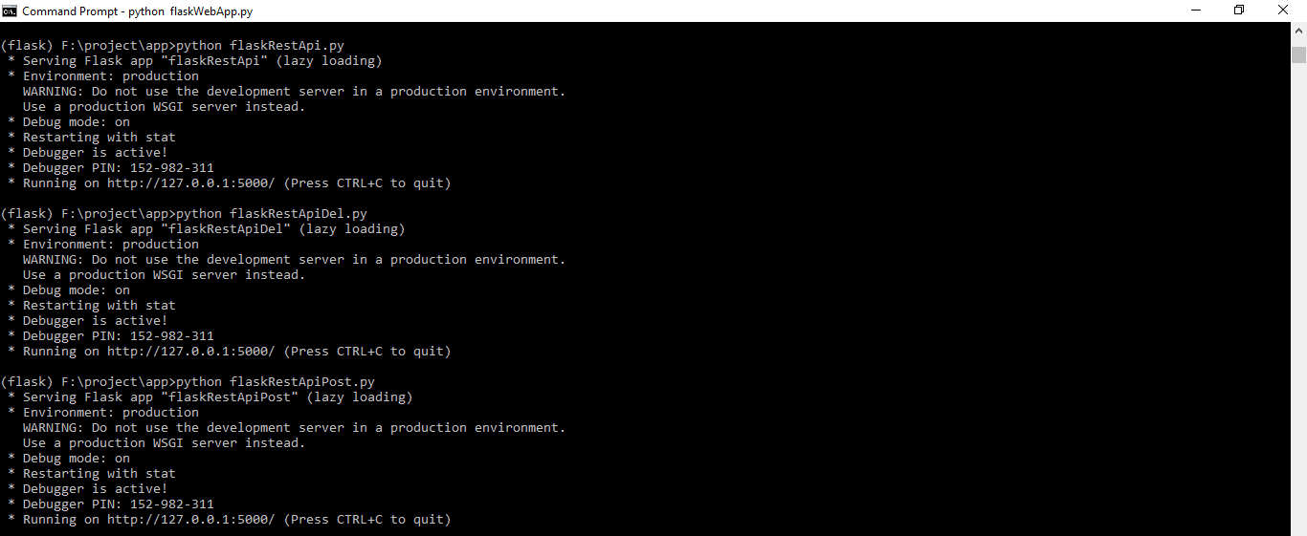

* Now create a file with name flaskRestApiDel.py in editor and write a code as bellow.

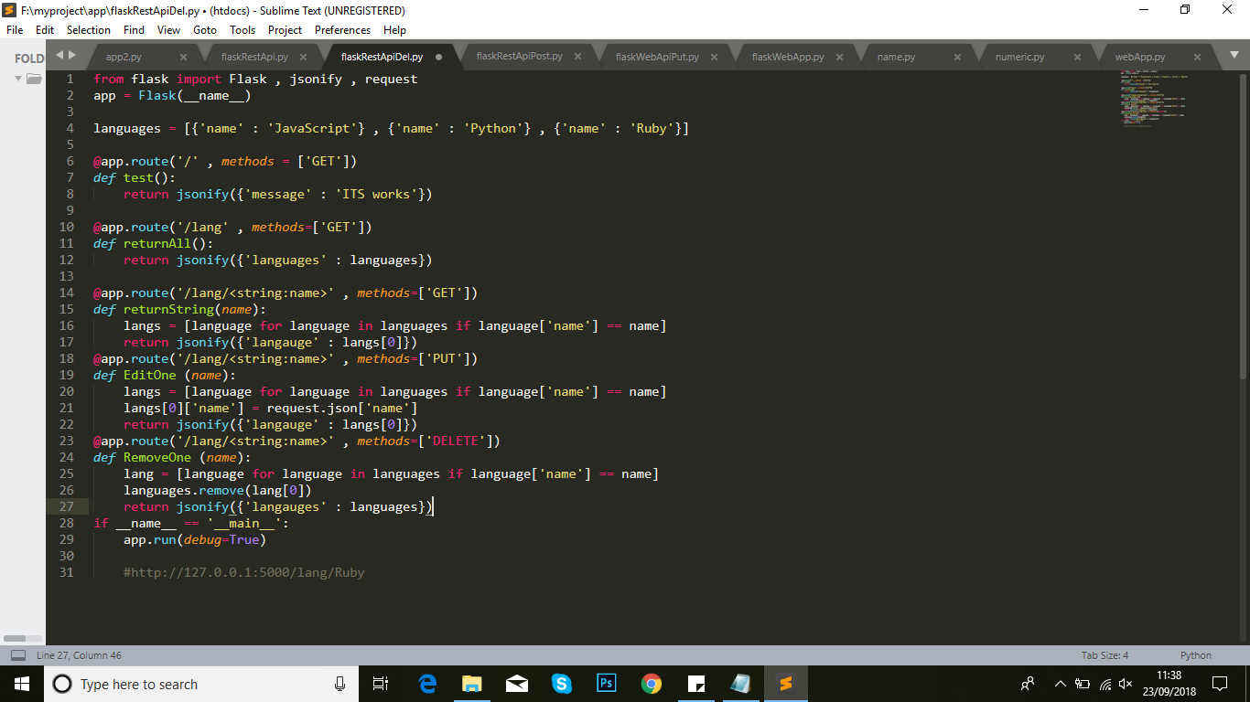

* After this run this file as



* Now create a file with name flaskRestApiPost.py in editor and write a code as bellow.

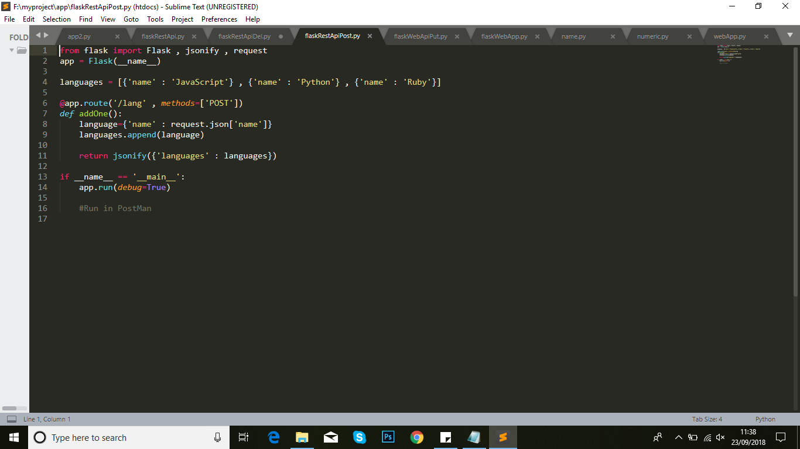

* After this run this file as



* Postman setup will show output.

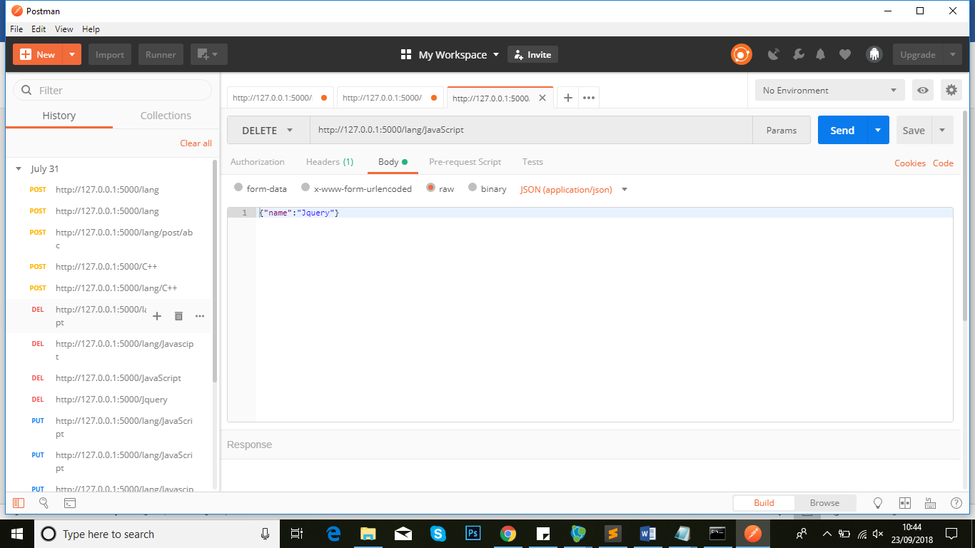

* Now create a file with name flaskRestApiPut.py in editor and write a code as bellow.

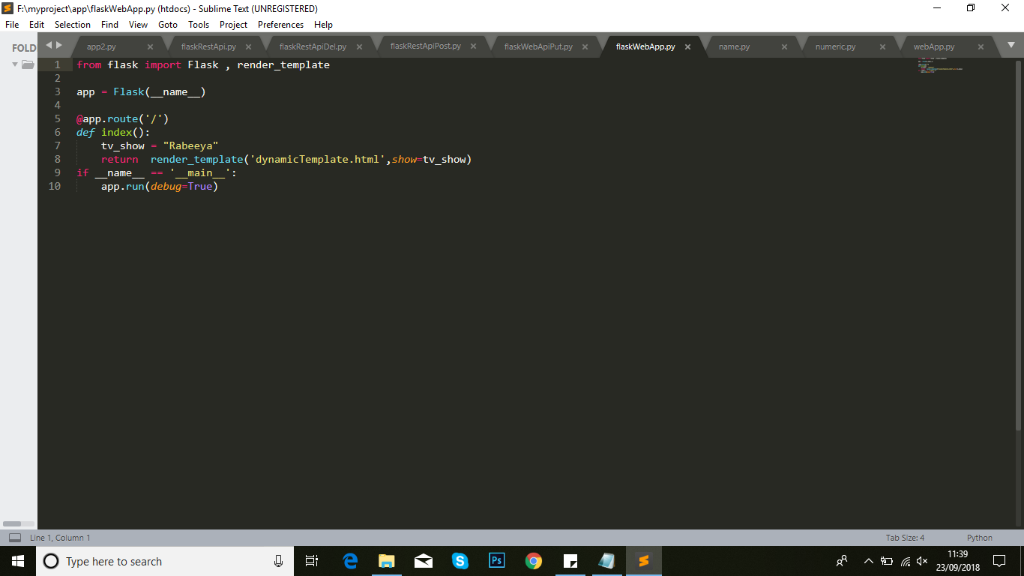

* After this run this file as

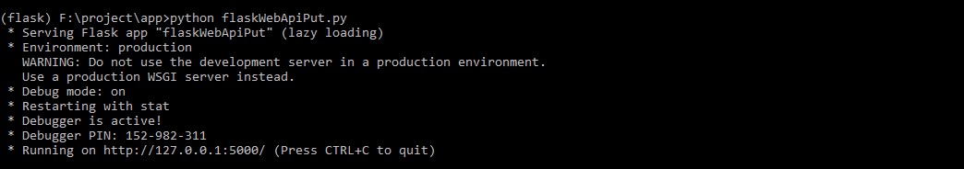

* Postman setup will show output.

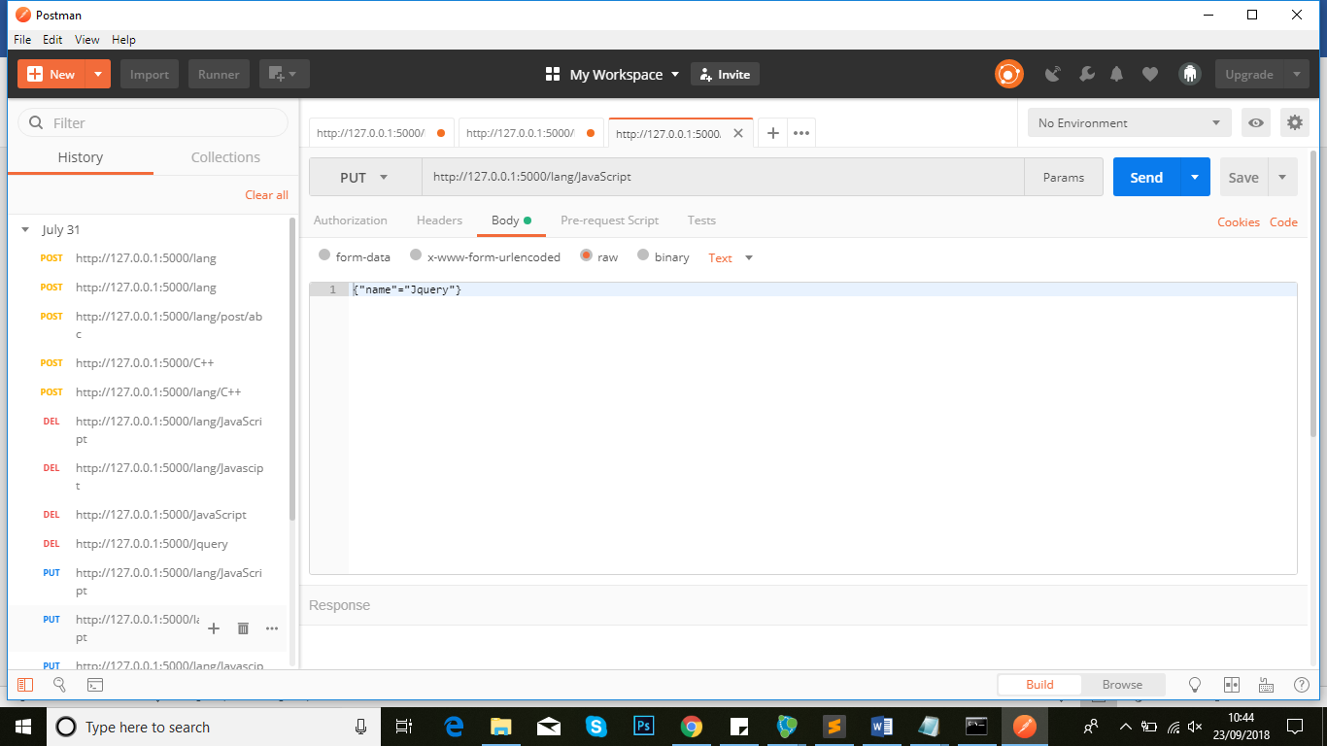

* Now create a file with name flaskWebApp.py in editor and write a code as bellow.

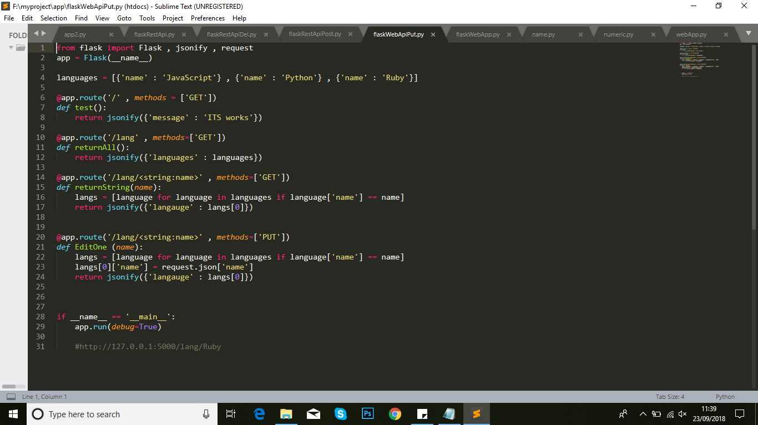

* After this run this file as

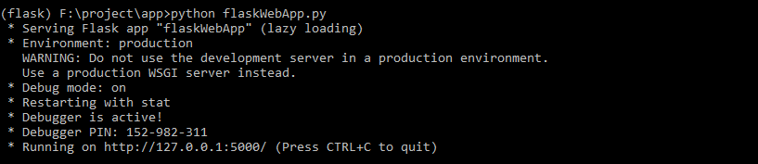

* Postman setup will show output.

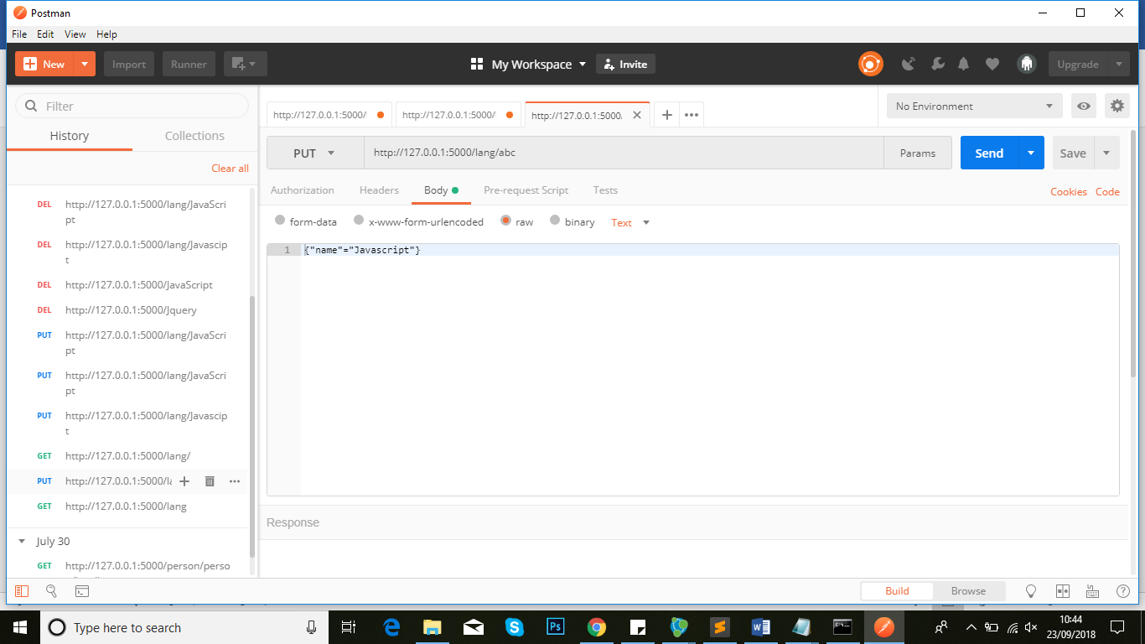

1. Now file create ExploreSocialDataModel.py that is used for hardcode data for creating graph database with different properties of nodes

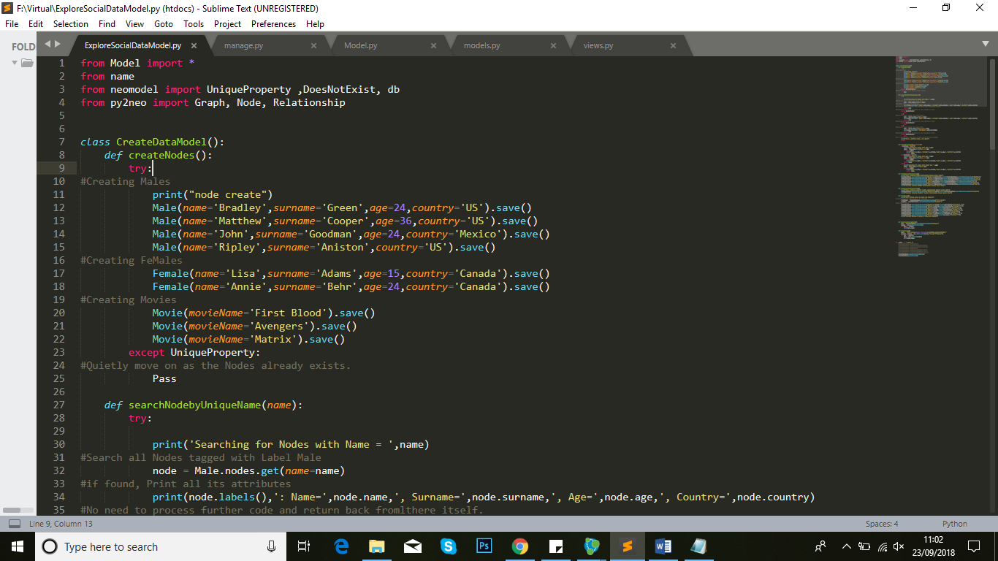

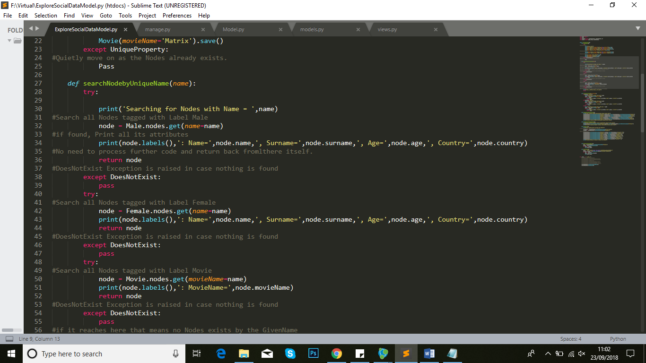

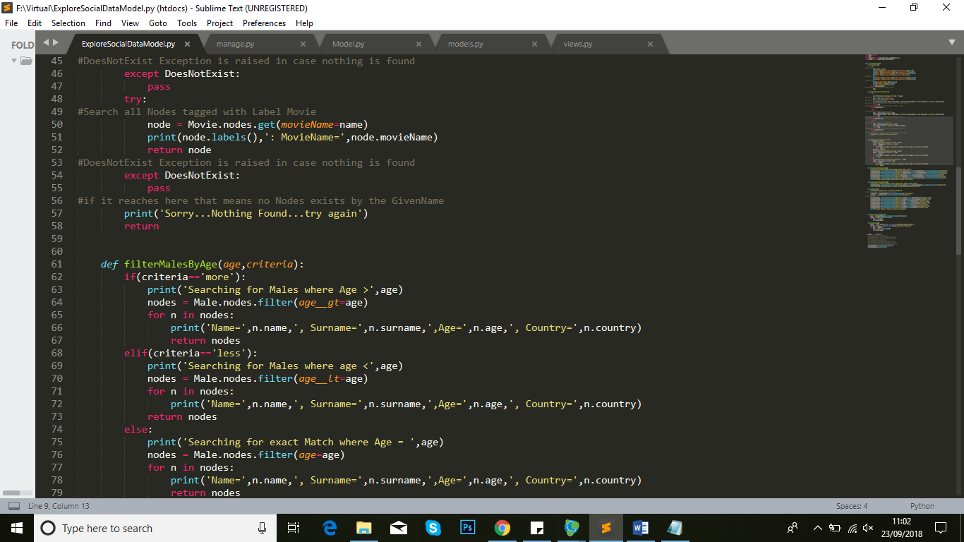

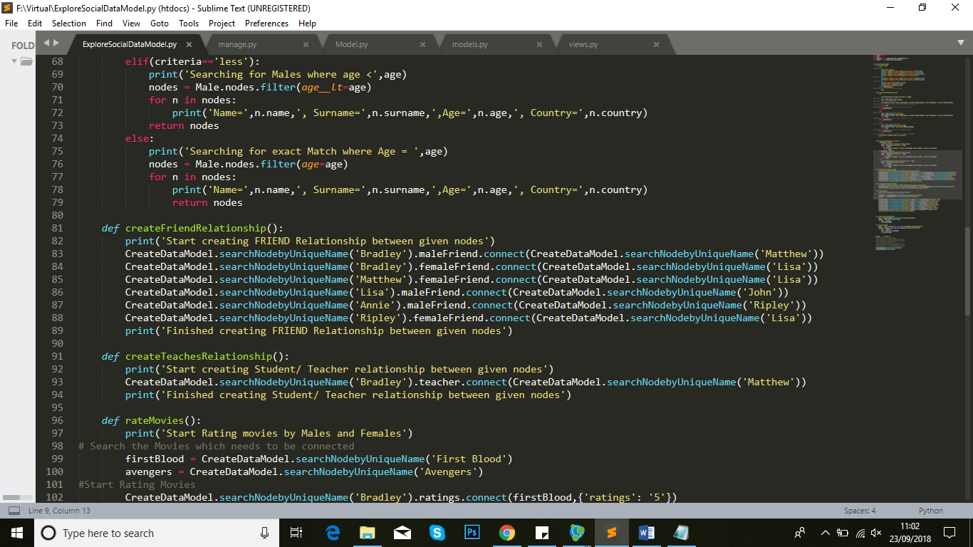

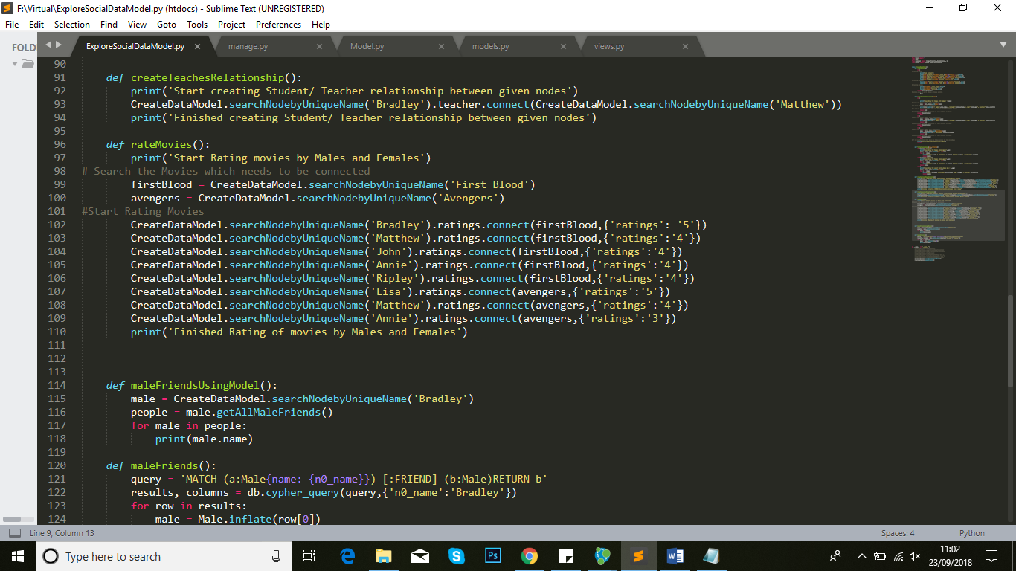

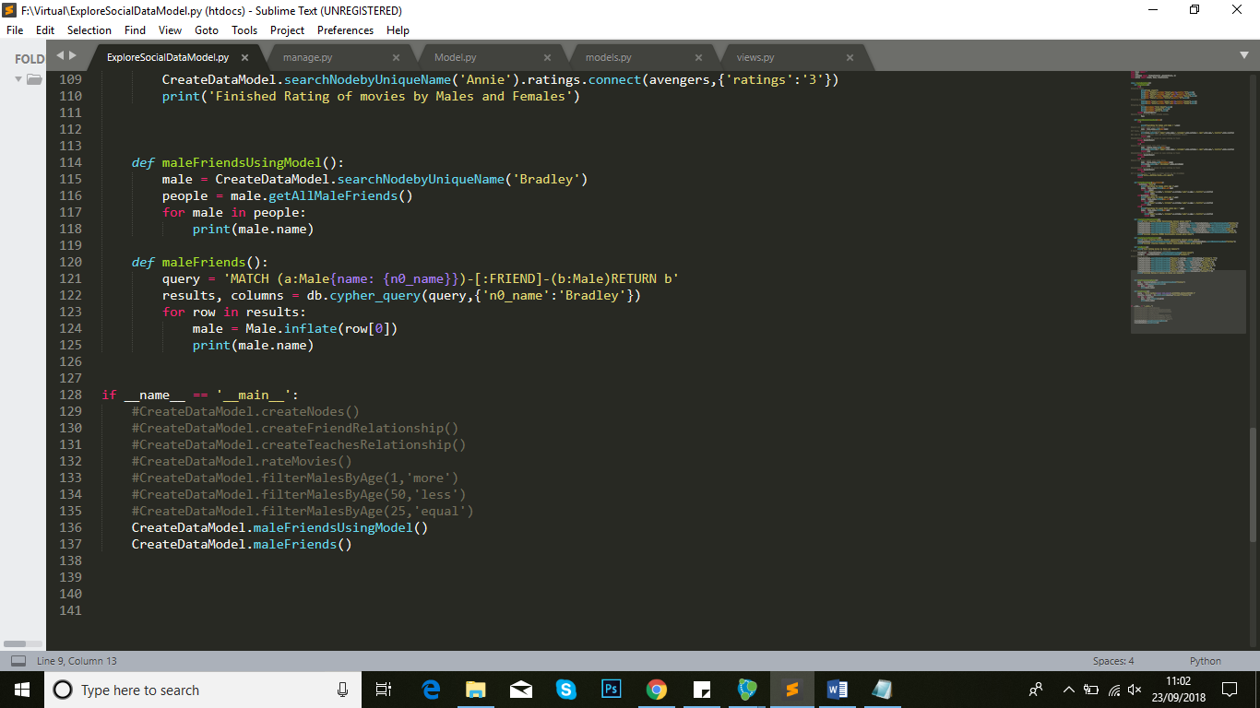

* Create file for model.py

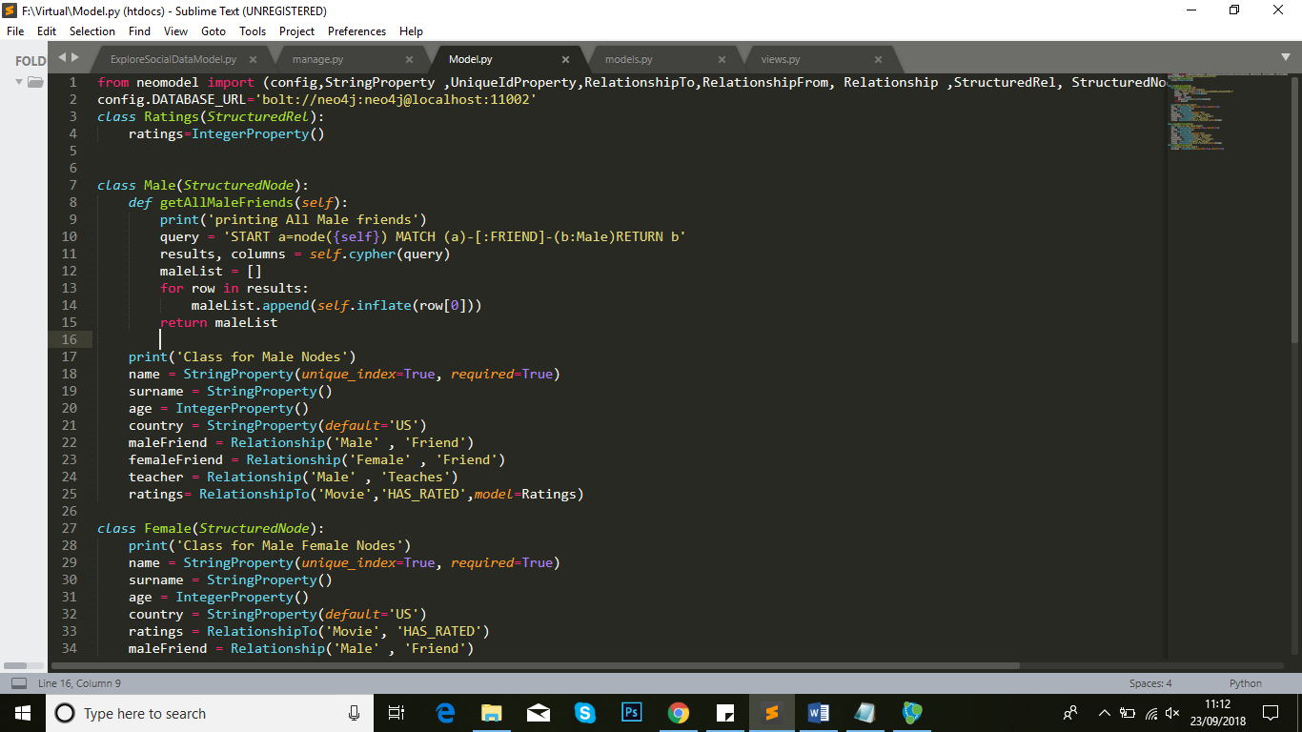

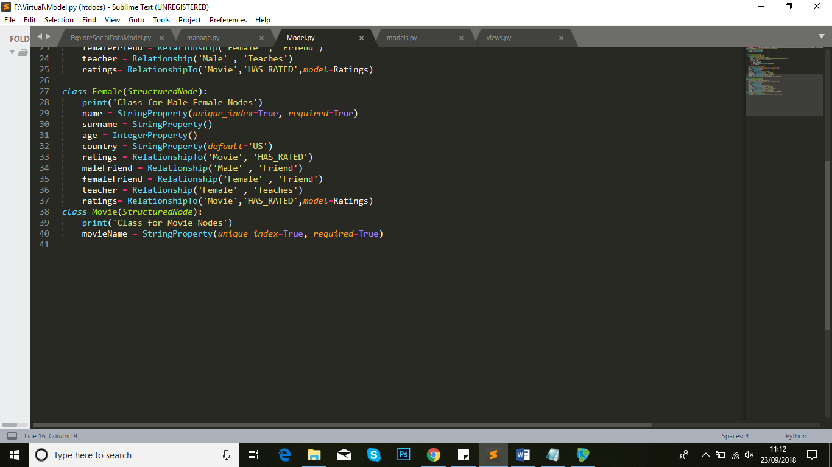

* That is the graph expression of nodes and relationship In neo4j.

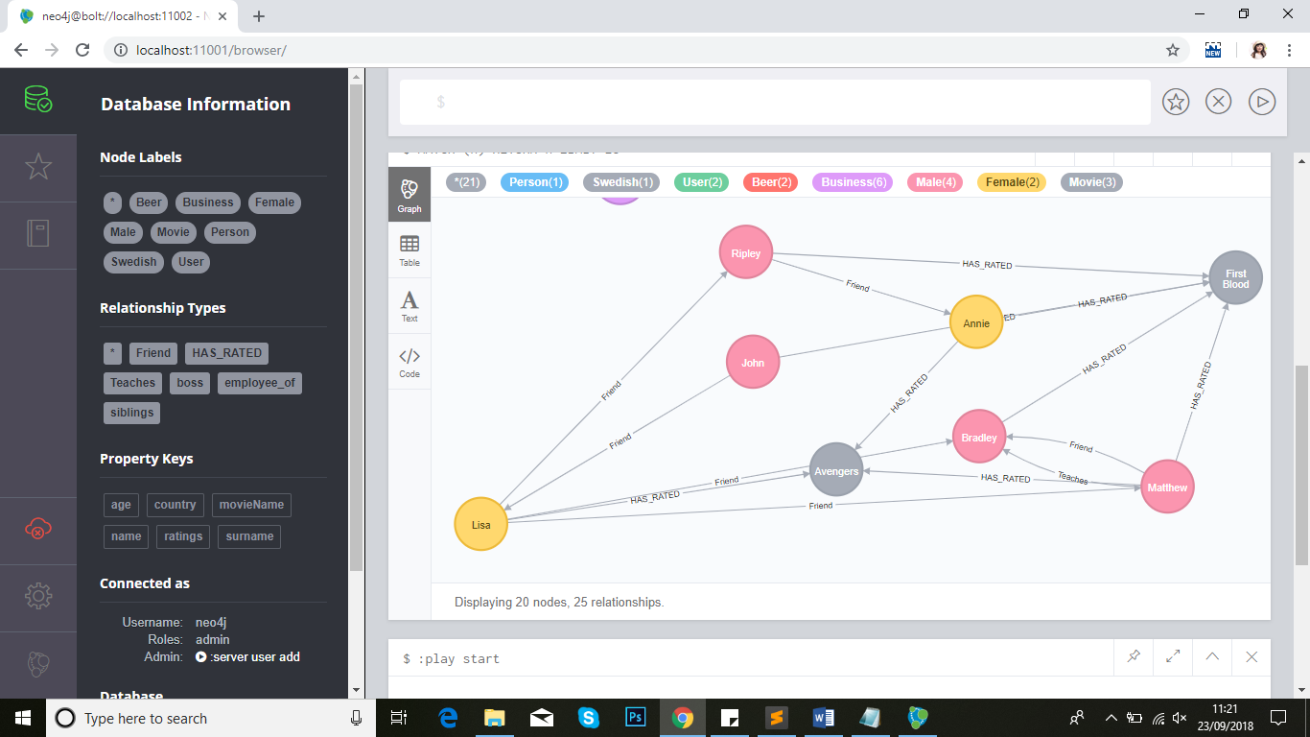

1. Now with user input we have connection of flask (user interface) with NLP that is NLTK(natural language toolkit) for creating graph in neo4j.

* Main.py

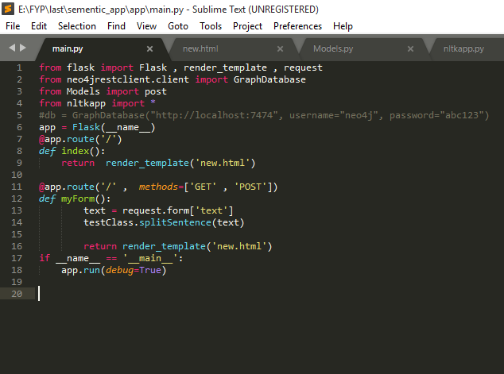

* New.html for user Interface.

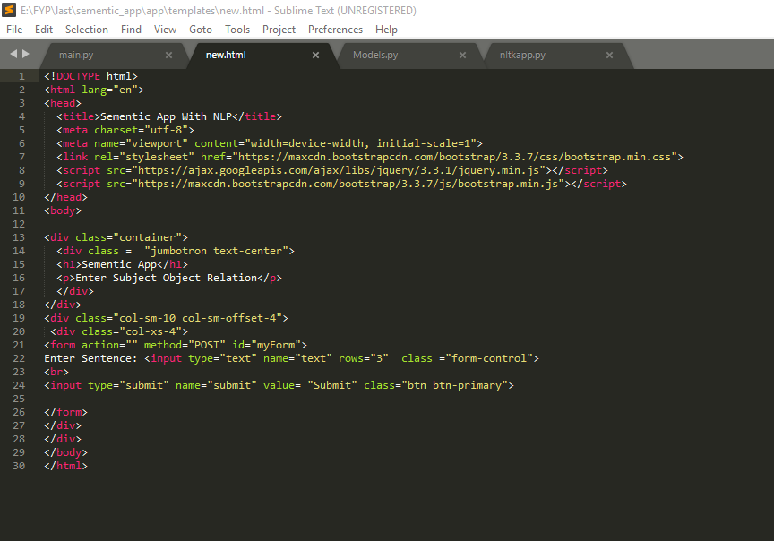

* Model.py

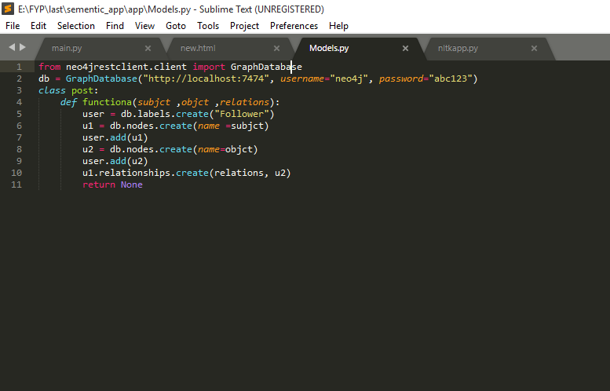

* NLP code in nltkapp.py

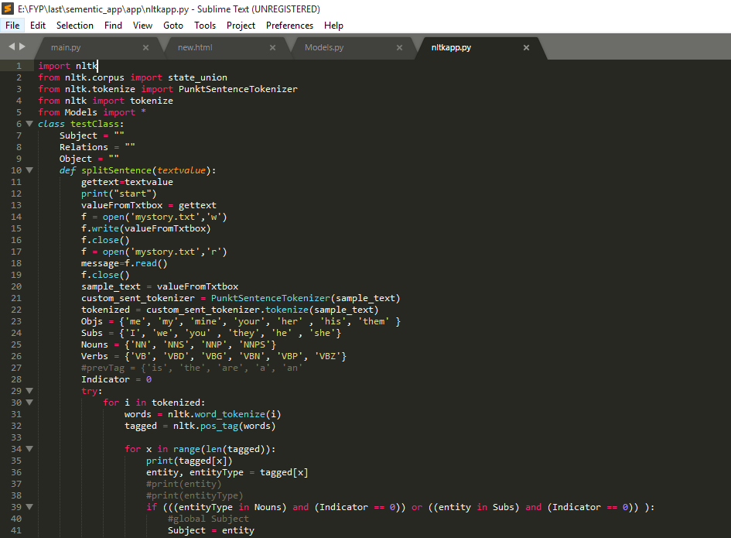

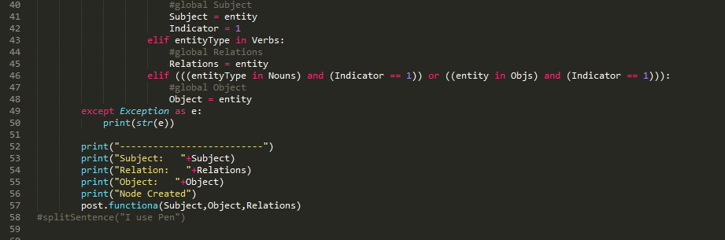

* Now output of our code after running it as

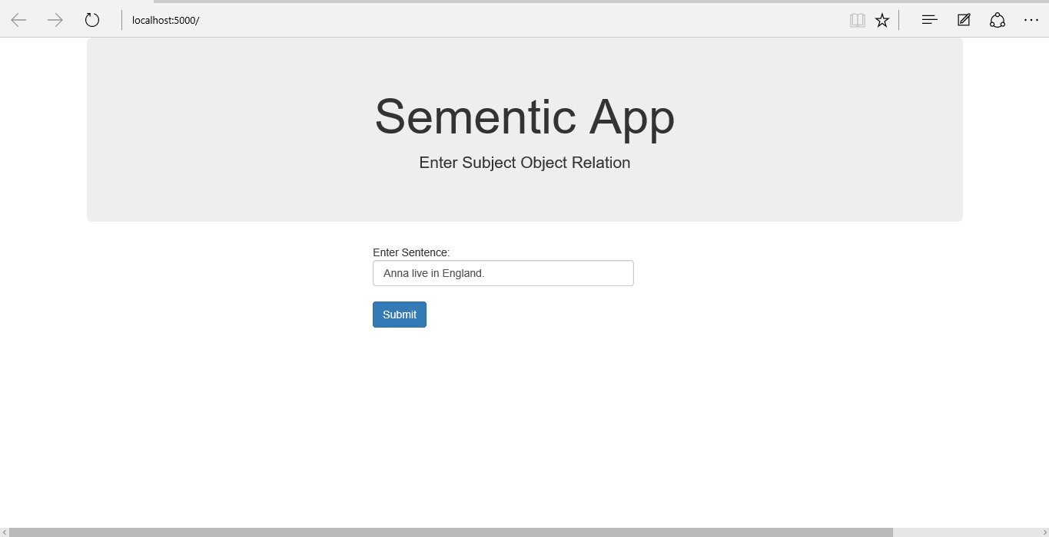

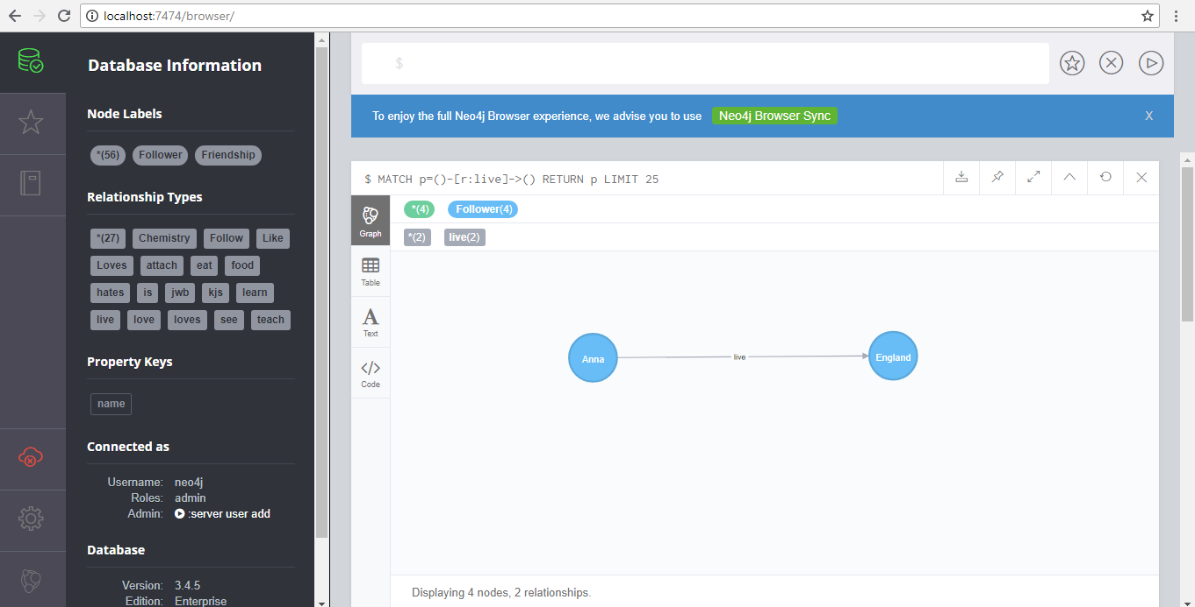

**1.6 Feasibility Study:**

**1.6.1 Technical feasibility:**

Semantic based knowledge system is a web app. Technically, in semantic based we are required to use some sort of graph database because in semantic systems database maybe complex and changes may occur after implementation. For graph database implementation we have to use neo4j with cypher query language. Whenever we think of semantic first question arise is:

What is technical interpretation of semantics? Which database is used for implementation of semantic system? Why we can’t implement relational database rather that graph database? Why we need to connect neo4j and flask? What is the functionality of flask? Why py2neo is used? Can we extract data from sentence or we should pass separate word? All these questions are arising while developing a semantic base application.

Semantics is an emerging field of research and development in information science, however, the concept has been around for a lot longer than computers.

Graph Database is use for implementation of semantic system because nodes in graph have properties of node and represent a great and understandable model of database. In RDBMS, for implementation of relationship we need foreign and primary keys that cause failure to get desired output in complex databases. But in Graph Database, with graphical representation interpretation is easy and efficient.

As in today’s era where technology progression is on its peak, there are many problems which occur during database extraction and storing. Graph is the easiest way to save complex data and extract it easily using neo4j cypher queries. We can create from basic to complex type of database using cypher. We can plot graph in neo4j using cypher queries but if a non-technical person wants to save data in in form of graphs. For this purpose, we are need to choose a language which will provide us user-interface. We use python and to provide it a web app view we use flask. After providing interface our web app needs a backend data storage.

Flask is a micro web framework written in python. It will provide you URL to access your web page through local host. It is used to design visual portion of web application. Yes, we can provide both interfaces.

But when we want to create connection between flask and neo4j we need py2neo that act as a bridge between flask and neo4j. py2neo connect with neo4j and flask connected.

If we are going to work without NLP then we have to take input word by word. But in case where NLP is used, a whole sentence is taken as input and processes to extract subject, object, predicate, intent and extra information separately.

**Flow Diagram:**

Flow diagram represent the flow of system. How the system starts and work to show the output of entered input. It’s a semantic base knowledge learner, data moves to decision phase after system validations to take decision either it should store in database or extract information and perform function to show desired output to user.

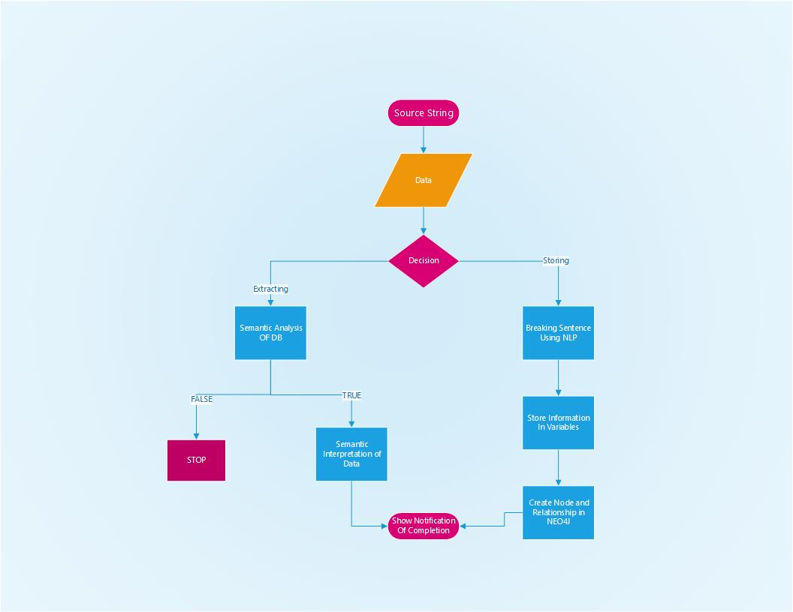

Figure 1. Flow Diagram of Semantic Base Knowledge Learner

**Flow without NLP:**

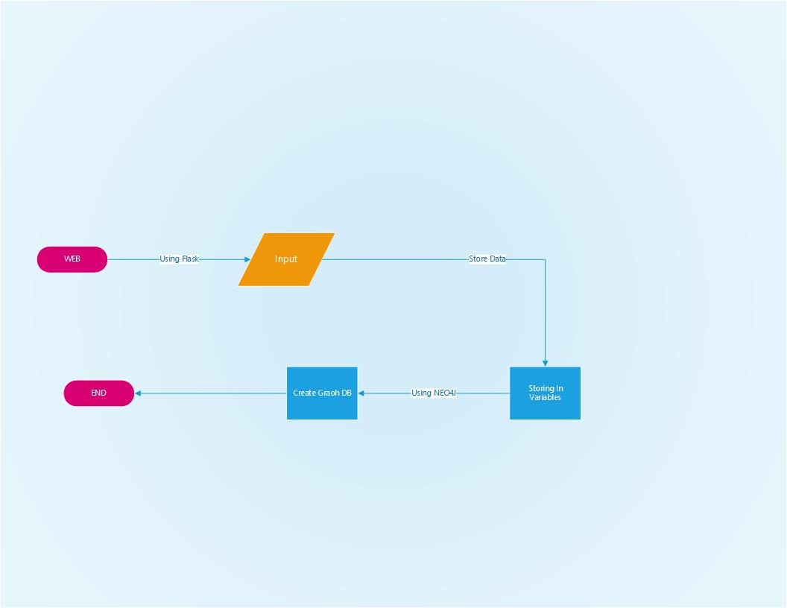

Figure 2.Prototype Flow without NLP

**Prototype Without NLP:**

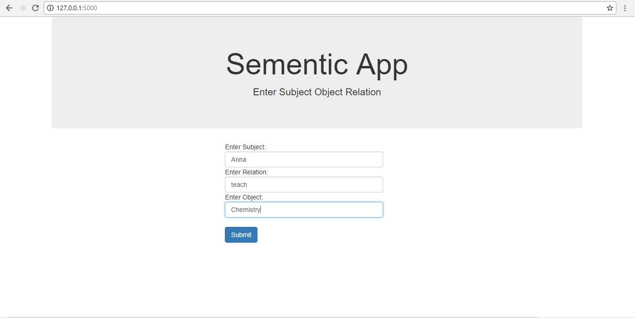

Figure 3: Web Interface of Prototype without NLP

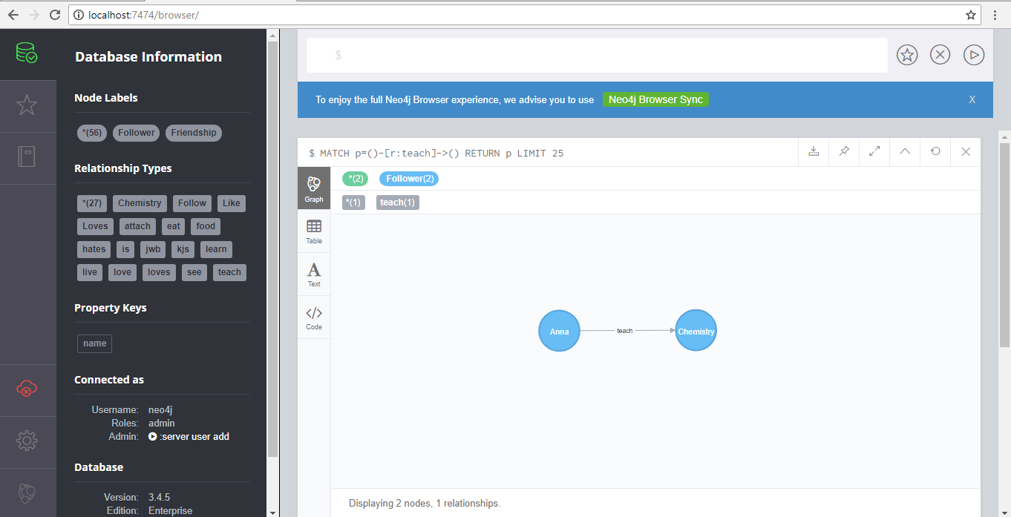

Figure 4:neo4j Graph of Prototype without NLP

**1.6.1.2. Flow with NLP:**

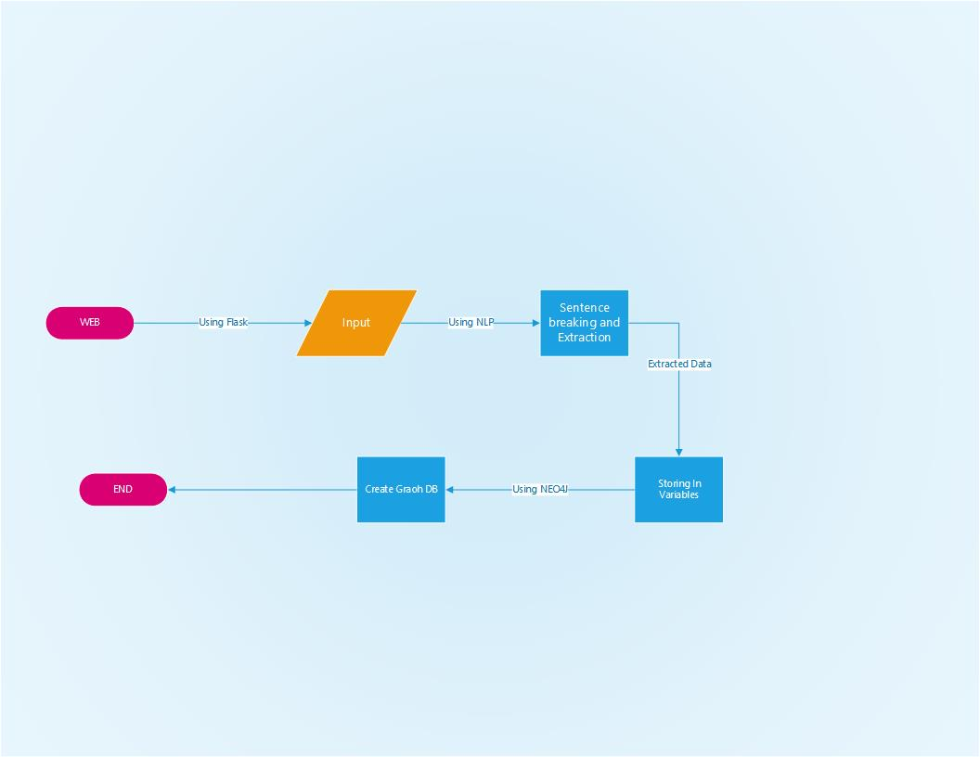

Figure 5.Prototype Flow with NLP

**Prototype Demo with NLP:**



Figure 6. Web Interface of Prototype with NLP



Figure 7. Neo4j Graph of Prototype with NLP

**1.6.2 Operational Feasibility:**

Our system is operationally feasible because there is no expensive system required and no specific environmental factors to install. The system will provide you with a guide to use it properly but you are required to have some knowledge about it.

**1.6.3 Economic Feasibility:**

There are many systems which are working in different institute which require different kind of hardware to work properly. But the system is web app which have no need of any specific hardware to use. The only cost that we need if system is implemented withAlexa (audio device) with cost estimation is Rs. 25000/- to Rs. 30000/- that we take directly or indirectly from departmental funds.

**1.7 Project Plan:**

|  |  |  |  |  |
| --- | --- | --- | --- | --- |
| **Name Of Students** | **July** | **August** | **September** | **October** |
| Umair | * Neo4j download & install * Draw graph using cypher * Story writing * Design RDBMS of story | * Use NLTK for basic NLP * For Feasibility report: * Explore existing news aggregators * Study Comparison and limitation of existing systems | * Project Plan * Wireframes * Survey for existing system * Explore complex NLP tool | * Survey to news Channel (store data) * Abstract * Apply explored NLP |
| Huma | * Neo4j download & install * Draw graph using cypher * Update story | * Explore flask and Neomodels * For feasibility report: * Introduction * Background * scope * motivation | * Project Plan * Update overview * Problem statement * Explore complex NLP tool | * Survey to news Channel (store data) * Objective * Functional & non-functional Requirements * Apply explored NLP |
| Rabeeya | * Neo4j download & install * Install Python, establish connection between python and neo4j * Story writing * Design DB for updated story | * Implementation of UI with Flask * Implementation of NeoModel for connection of flask with neo4j * For feasibility report: * Technical feasibility * Basic flow Diagram | * Project Plan * Tutorial Session * Relational attribute for hardcode input * Explore complex NLP tool | * Survey to news Channel (Extraction of data) * Technical & budgetary risk * System Specification * Apply explored NLP |
| Batool | * Neo4j download & install * Draw graph using cypher * Implement Rest-API’s * Prove How RDBMS fails and describe benefit of Graph Database | * Connection of Python with neo4j and with hardcode input draw graph in neo4j * For feasibility report: * Operational Feasibility * Economical Feasibility | * Project Plan * Tutorial Session * Relational attribute for user Input * Explore complex NLP tool | * Survey to news Channel (Extraction of data) * Industrial & market risk * Target area & beneficially * Apply explored NLP |

|  |  |  |  |
| --- | --- | --- | --- |
| **Name Of Students** | **November** | **December** | **January** |
| Umair | * External Interface Requirements * NLP implementation with complexed sentences(finalized) | * DB design * Class Diagram * Extend NLP with Paragraph and web Scraping | * Integration of UI with NLP * Preparation for Presentation * Thesis Writing |
| Huma | * Use Cases * Introduction * System Features * Interface in Flask | * Test Cases * ERD * Extend NLP with Paragraph and web Scraping | * Integration of UI with NLP * Preparation for Presentation * Thesis Writing |
| Rabeeya | * Overall Description * Use Cases * NLP implementation with complexed sentences(finalized) | * Test Cases * DFD (data flow diagram) * Queries to Extract desired output from graph database | * Integration of UI with NLP * Preparation for Presentation * Thesis Writing |
| Batool | * Non-functional Requirements * Interface in Flask | * Sequence diagram * Use Case diagram * Queries to Extract desired output from graph database | * Integration of UI with NLP * Preparation for Presentation * Thesis Writing |

**1.8 Wireframes:**

* **Homepage**

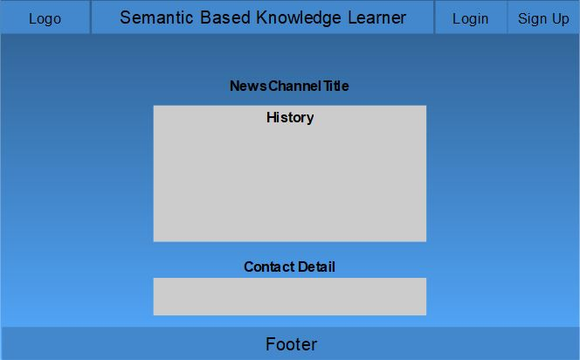

* **Signup & Login**

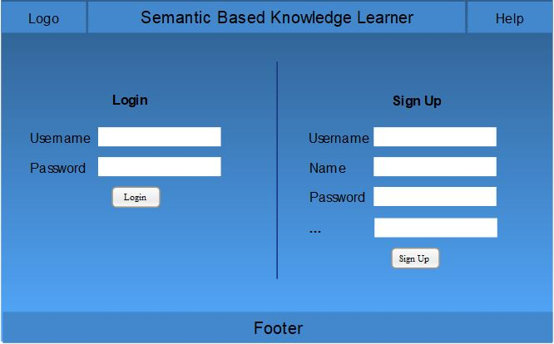

* **Profile**

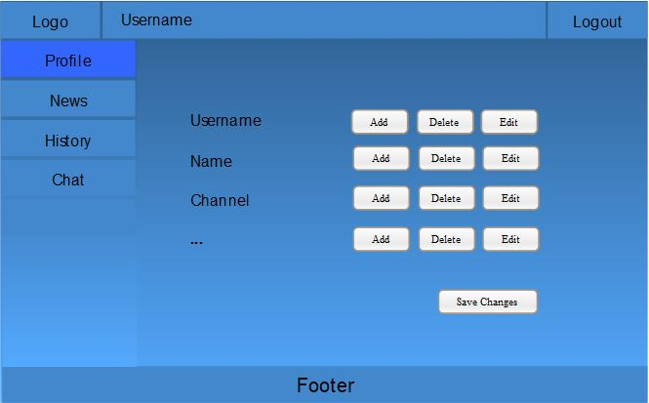

* **Add News**

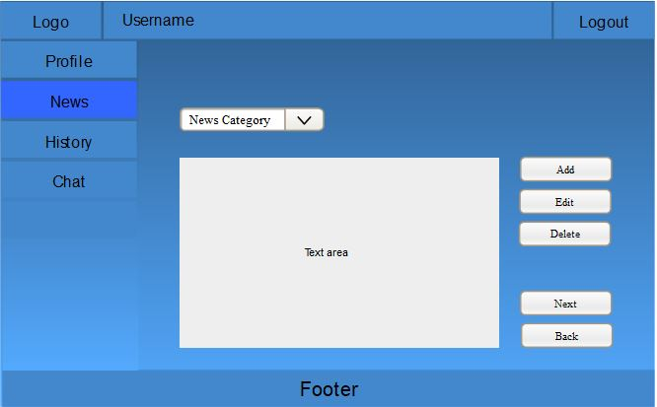

* **Extract News**

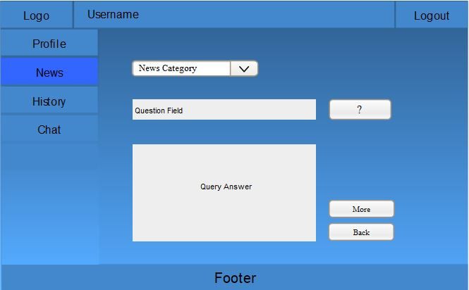

* **History**

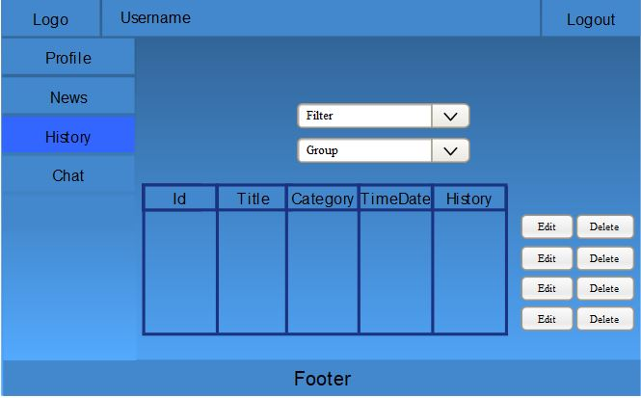

* **History of Add News**

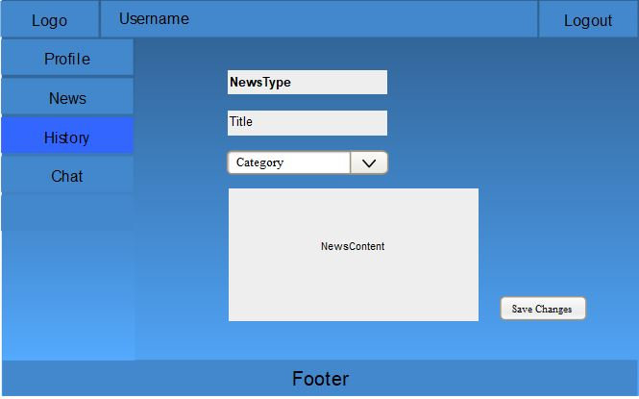

* **History of Edit News**

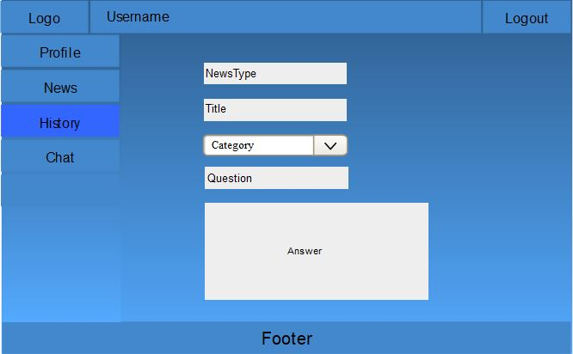

**1.9 System Requirements:**

**1.9.1 Hardware Requirement:**

|  |  |  |
| --- | --- | --- |
| **Sr. No** | **Component** | **Requirements** |
| 1. | Available Ram | Minimum 4GB |
| 2. | Disk Space or Hard | Minimum 500GB |
| 3. | Processor | Minimum [corei5@2.2GHz](mailto:corei5@2.2GHz) |
| 4. | Audio Device (Optional) | Alexa |

**1.9.2 Software Requirement:**

|  |  |  |
| --- | --- | --- |
| **Sr. No** | **Component** | **Description** |
| 1. | Operating system | Window 10 (64bit) |
| 2. | Neo4j | Graph Database (v 3.4.2) |
| 3. | Python IDE | Python 3.7.0 |
| 4. | Flask | Python Web framework |
| 5. | Py2neo | Connector b/w flask and neo4j |

**1.10 Limitation and Challenges in Implementation of Project:**

* Connection between neo4j, py2neo and flask cause error because of incompatibility of version, indentation or syntactical error.
* NLP(natural language processing) interpretation is the major task as to search the compatible API with python Language.
* Due to largest paragraph, interpretation will be difficult.
* Presentation to user to provide them complete guideline also be a great challenge.
* During audio input, error maybe occur due to human fault or environmental issue.
* Except of image processing system have to get data from any file and text input that maybe a great challenge.

**1.11 References:**

[1]. Gupta, S. (2015). Building web applications with Python and Neo4j. Birmingham, UK: Packet Publishing.

[2]. Lutz, M. (2018). Learning Python. [online] Shop.oreilly.com. Available at: <http://shop.oreilly.com/product/0636920028154.do>.

[3]. Robinson, I. (2018). Graph Databases. 2nd ed.

[4]. YouTube. (2018). Natural Language Processing with Python and NLTK p.1 Tokenizing words and Sentences. [online] Available at:

https://www.youtube.com/watch?v=FLZvOKSCkxY.

[5]. YouTube. (2018). Creating a Restful API With Flask [1 of 4] - Get Requests. [online] Available at: https://www.youtube.com/watch?v=CjYKrbq8BCw.

[6]. Neo4j Graph Database Platform. (2018). Python Graph Database | Neo4j. [online] Available at: https://neo4j.com/developer/python/.

[7]. Neo4j Graph Database Platform. (2018). Python Graph Database | Neo4j. [online] Available at: https://neo4j.com/developer/flask/.

[8]. Neo4j Graph Database Platform. (2018). Python Graph Database | Neo4j. [online] Available at: https://neo4j.com/developer/py2neo/.

[9]. En.wikipedia.org. (2018). Semantics. [online] Available at:

<https://en.wikipedia.org/wiki/Semantics>.

[10].Neo4j Graph Database Platform. (2018). RDF Triple Stores vs. Labelled Property Graphs: What's the Difference?[online] Available at:

<https://neo4j.com/blog/rdf-triple-store-vs-labeled-property-graph-difference/>

[11]. Anon, (2018). [online] Available at:

<https://www.researchgate.net/publication/221565269_RELEVANTNews_A_semantic_news_feed_aggregator>

**[**12]. Ijird.com. (2018). [online] Available at:

http://www.ijird.com/index.php/ijird/article/viewFile/66596/52147.

[13]. J. Hendler, "Semantic Web: The Insider Story," 2014. [Online]. Available: <http://www.slideshare.net/jahendler/semantic-web-the-inside-story>

[14]. Neo4j Graph Database Platform. (2018). RDF Triple Stores vs. Labelled Property Graphs: What's the difference? [online] Available at: <https://neo4j.com/blog/rdf-triple-store-vs-labeled-property-graph-difference/>

[15]. Anon, (2018). [online] Available at:<https://www.quora.com/Semantic-Web-Exactly-what-is-the-difference-between-a-triplestore-and-graph-store-examples>